Developer and User Documentation

Deep Learning-based Underbody Vehicle Automated Wireless Inspection System

Table of Contents

1.0 Introduction 3

2.0 Deep Learning 3

3.0 Setup 4

3.1 CUDA Installation 4

3.2 Training Process 8

3.2.1 YOLOv7 8

3.2.2 YOLOv8 12

3.2.3 YOLOv9c 14

4.0 Raspberry Pi Zero WH 15

4.1 Components Requirements 15

4.2 Setup 19

4.3 Signal Communication Codes 25

5.0 Jetson Orin Nano 28

5.1 Setup Using SDK Manager 28

5.2 PyCharm Community Installation 32

5.3 CUDA Installation 34

5.4 MySQL & PhpMyAdmin Installation and Activation 36

5.5 Website 39

6.0 Limitation 42

7.0 Improvements 42

8.0 Future Work Implementation 43

9.0 Error Analysis 44

10.0 Sources 44

11.0 Appendix 46

# Introduction

This documentation demonstrates and explains the procedures to create this project, titled “Deep Learning-based Underbody Vehicle Automated Wireless Inspection System”. It is a underbody vehicle inspection system that utilizes deep learning model, namely YOLO to help detects the part defect underneath the vehicle which is looseness of bolt by analysing the bracket and the washer friction through a wireless camera. This system allows user to undergo inspection process in a webpage with a press of a button and record the detected results to stored inside a database.

# Deep Learning

To determine whether the bolt is loose or tight fit, we can see it from the bracket and the washer friction. If the bracket is not horizontal then the it might be the bolt loose causing the bracket to be slanted. If the washer has a friction mark beside it, it means that the bolt might be loose and moves because its initial position is the position of the friction mark. Hence, we are able to determine the looseness of the bolt by looking at the position of the bracket and the appearance of the washer friction as shown in figure 2.1 and figure 2.2.

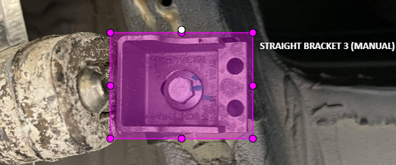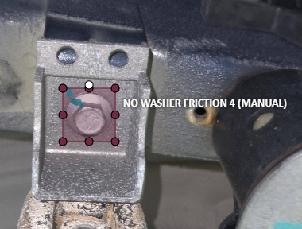

Figure 2.1 Bounding box for straight bracket and no washer friction

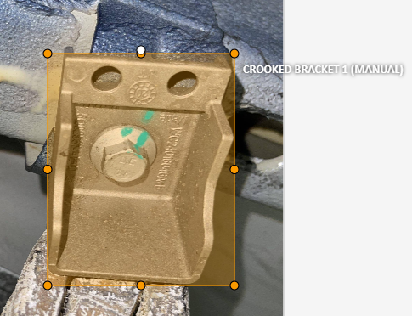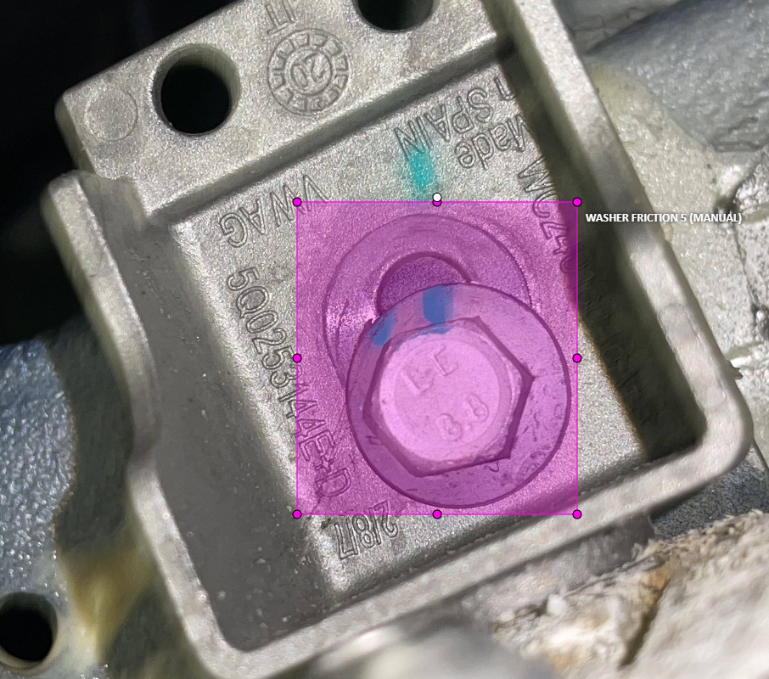

Figure 2.2 Bounding box for crooked bracket and washer friction

This project will used YOLOv9c to train the model. The amount of dataset are shown in table 2.1. The device specifications used for running the training session of YOLOv9c is also shown in table 2.2 which is a MSI laptop. Furthermore, we will be using PyCharm community and Pytorch framework with CUDA support to use our GPU to train the model in order to speed up the process.

Table 2.1 Dataset allocation of dataset for train, test and validation

|  |  |  |  |  |
| --- | --- | --- | --- | --- |
| **Dataset** | **Training**  **images** | **Validating**  **images** | **Testing**  **images** | **Total** |
| Bolt on exhaust mounting | 948 | 120 | 117 | 1185 |

Table 2.2 MSI laptop specifications

|  |  |
| --- | --- |
| **Parameters** | **MSI Katana GF66 12UD** |
| GPU | NVIDIA® GeForce RTX™ 3050 Ti Laptop GPU 8GB GDDR6 Up to 1460MHz Boost Clock 140W |
| CPU | 12th Gen Intel® Core™ i7 Processor |
| Memory | 16 GB 2GB |
| Storage | 1TB SSD |
| CUDA | 12.1 Supported |

# Setup

This section will explain the process and steps to install CUDA and train the model, the purpose of using CUDA is to speed up the training process by using GPU instead of CPU.

## CUDA Installation

Before we start installing CUDA, we have to check whether our GPU of our device used for model training is supported with CUDA or not by checking it from the NVIDIA website [1]. Based on figure 3.1 from the website, it shows that our GPU is CUDA supported which is the GPU highlighted in yellow (GeForce RTX 3050 Ti).

Note that compute capability (newest is 8.6) and CUDA Toolkit version (newest is 12.0) are two different things. Compute capability is fixed for the hardware and says which instructions are supported, and CUDA Toolkit version is the version of the software you have installed. Hence, all we have to look is whether our GPU is in the table from the website or not, it is CUDA supported if it has compute capability of CUDA.

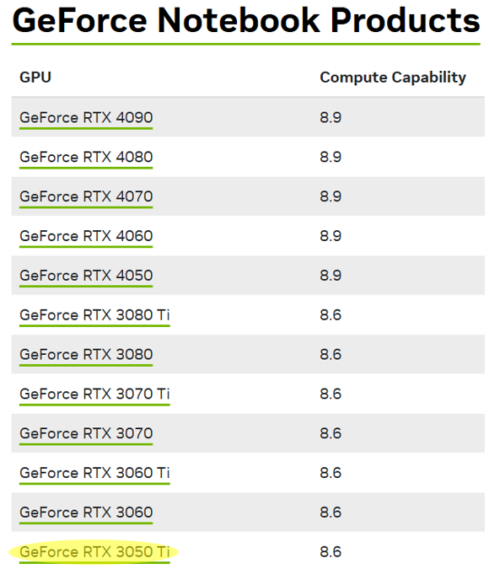

Figure 3.1 NVIDIA website table of GPU with CUDA support

After checking the support of CUDA for our GPU, there are two things we only need to do to have our CUDA up and running which is the installation of CUDA toolkit from the website [2] and the installation of PyTorch from their website [3].

*CUDA Toolkit Downloader*

From figure 3.2 which is the CUDA toolkit downloader website [2] based on version 12.1 CUDA, we can select the parameters which are Windows, x84_64 architecture, 11 version and exe(network) installation type. Lastly, pressed the download button and run the installation once downloaded.

*PyTorch with 12.1 CUDA support*

Figure 3.3 shows the PyTorch installation website [3] where we can obtain the command to download the PyTorch with CUDA version 12.1 supports. We select the parameters according to figure 3.3 which are Stable (2.3.0) for PyTorch build, Windows, Pip package, Python language and CUDA 12.1. There will be a command displayed below the parameters we selected after we have picked all the options, we have to copy the command to our clipboard first.

To run this command, we must open a new project folder with python file and environment name in PyCharm Community. We can paste the command we copied to the terminal of the python project folder and we wait until the installation is complete.

*Checking of CUDA activation*

To check whether we the CUDA of our device has been activated or not, we can paste the following code as shown in figure 3.4 in the python file from the project folder and run the codes. We should get the following output as shown in figure 3.5 if we done the step correctly and the CUDA has been activated.

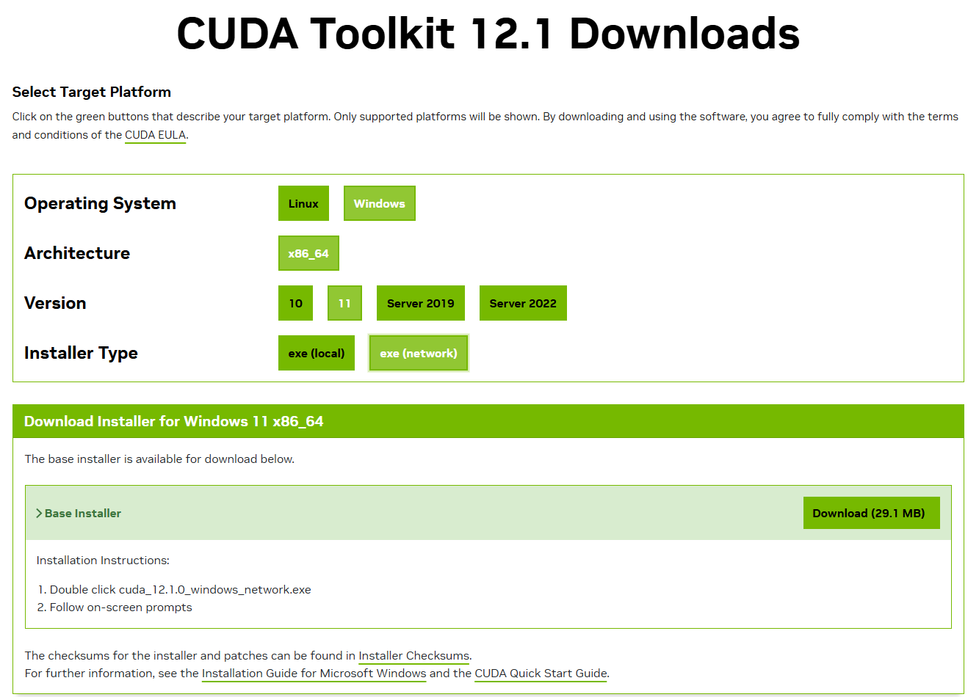

Figure 3.2 CUDA Toolkit 12.1 Downloader Website

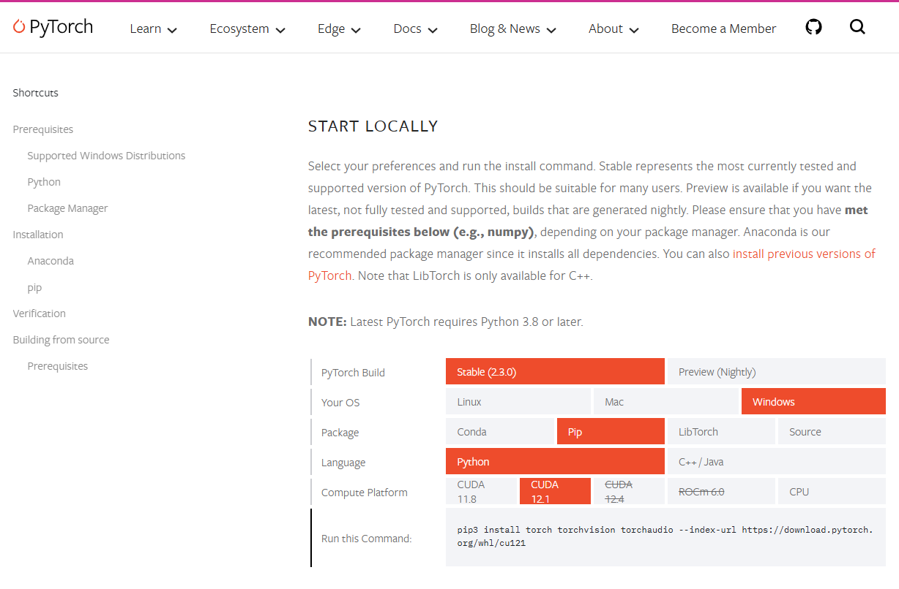

Figure 3.3 Pytorch with 12.1 CUDA support downloader website

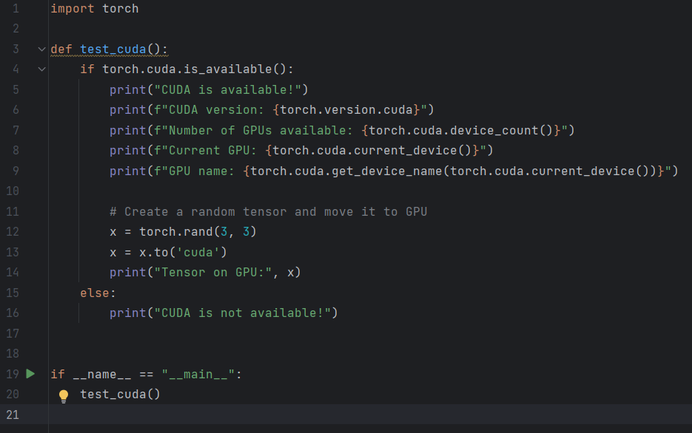

Figure 3.4 Code for CUDA test

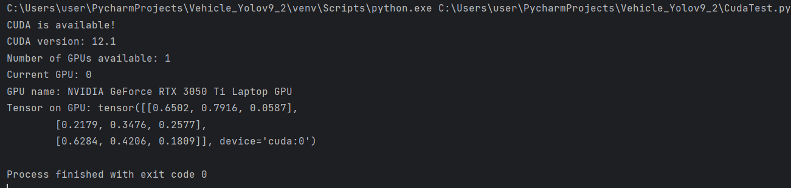

Figure 3.5 Output obtained from codes of CUDA test

## Training Process

After the CUDA is up and running, we can begin the next part of our training process which is to arrange the dataset folder accordingly. We can create a data folder which consists of three sub-folders train, test and valid. Each of these sub-folders should have its own sub-folder which consists of image and label folders. The folder structure looks like in figure 3.6 and make sure the folder structure is in desired directory, in our case is in our PyCharm project folder. In the next few sections, we will be talking about the running of each YOLO versions for training process due to different approaches to run each version to train.

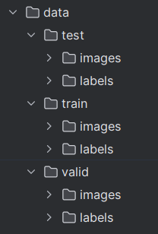

Figure 3.6 Data folder structure

## YOLOv7

For YOLOv7, we will begin by downloading the YOLOv7 zip folder and YOLOv7.pt file provided by Wong Kin You from the GitHub [4]. After that, we extract the folder and move the folder to our PyCharm project folder renaming as “yolov7-custom” while the YOLOv7.pt file we move it into “yolov7-custom” folder with the folder structure illustrated in figure 3.7.

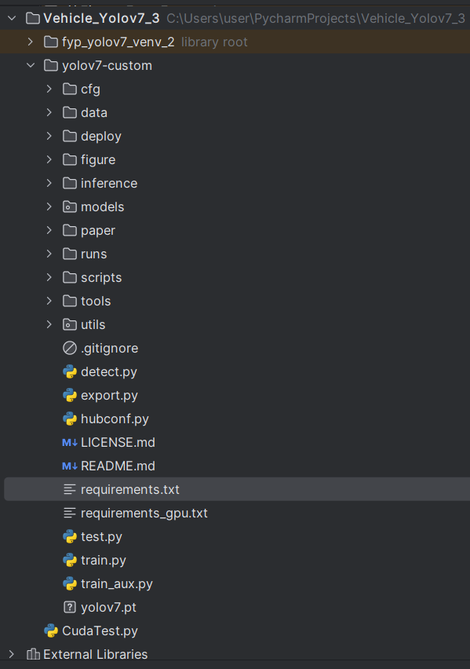

Figure 3.7 YOLOv7 project folder structure

Since we already have a CUDA up and running, we opened the requirement.txt file and remove the code at line 11 and line 12 which indicate torch and torchvision because these two line of codes will interrupt our CUDA. Then we run copy the command from the first line of the code and run in the terminal of the PyCharm project, it will install all the necessary libraries for running YOLOv7 later.

In the next step, we move our train, test and valid folders which we created in the previous section to the data folder of “yolov7-custom” folder as illustrated in figure 3.8. Then we create another .yaml file with the name “custom_data.yaml” in the data folder and type the codes as shown in figure 3.9, this will help the system to find the data folder.

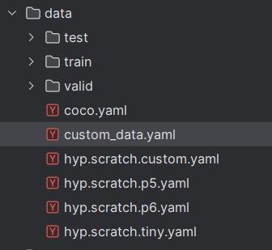

Figure 3.8 Data folder structure in “yolov7-custom”

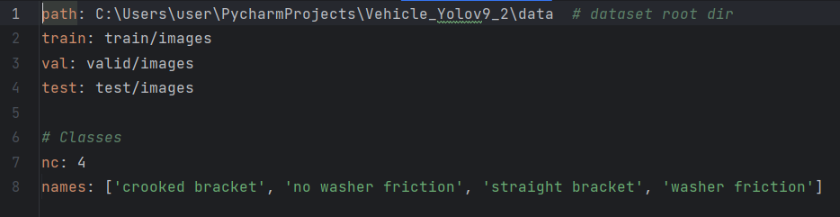

Figure 3.9 Codes for “custom_data.yaml”

In the last step before we begin our training, we head into our “training” folder which is in “cfg” folder then we duplicate “yolov7.yaml” with the name “yolov7-custom.yaml”. Then we set “nc” from 80 to 1 as shown in figure 3.10.

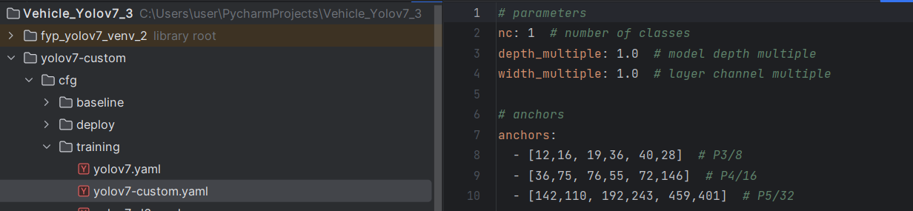

Figure 3.10 Codes and folder structure for “yolov7-custom.yaml”

Finally, we run the following command as shown in figure 3.11 in the terminal to begin the training process.



Figure 3.11 Codes for begin the training process

The explanation of the training command parameters are as follows:

*python train.py*

The Python script train.py is run in this part. It's possible that the script is in charge of the training.

*--workers 8*

This argument tells the computer how many worker processes to use to load data during training. If we set it to 8, 8 processes will load data at the same time. If we have a CPU with multiple cores, this can speed up training.

*--device 0*

This input tells the programme which device to train on. It is set to 0 in this case, which usually means the first GPU if one is available. We can set it to -1 if you don't have a GPU or want to use the CPU instead.

*--batch-size 4*

This argument tells the training algorithm how many pictures to process in each round. Every time the model is trained, it will look at four pictures at a time if the batch size is 4.

*--epochs 300*

This input sets the number of epochs, which means how many times the whole dataset will be fed to the model while it is being trained. When the model has been trained on every sample in the collection once, an epoch is over.

*--img 640 640*

This argument tells the model what size pictures to take in. It's set to 640x640 pixels in this case.

*--data data/custom_data.yaml*

We can use this argument to tell the programme where to find a YAML file with details about the training dataset. It most likely has information like the links to image files, classes, and annotations.

--*hyp data/hyp.scratch.custom.yaml*

This argument tells the programme where to find a YAML file with training settings for the model. Some examples of these hyperparameters are learning rate, momentum, weight loss, and so on.

*--cfg cfg\training\yolov7-custom.yaml*

This argument tells the programme where to find the model settings in a YAML file. It probably has information about how the network is set up, like how many levels, filters, etc.

*--name yolov7-custom*

The name of the model that is being learned is given by this argument. During and after training, it will be used to find the model.

*--weights yolov7.pt*

We can set the model's settings before training by using this argument to tell it where to find the weights file. The weights used in this case are named yolov7.pt and seem to have already been learned. These weights may have been trained on a different dataset or model architecture.

## YOLOv8

There are four things that we must do if we want use YOLOv8 to train the model which are moving data folders, download libraries, create python file for code to run the training and create a .yaml file. First, move our data folder which contains of train, test and valid folders into our main directory of YOLOv8 PyCharm project folder, the folder structure looks like in figure 3.12.

The Next thing we have to do is to install Ultralytics library in our PyCharm project by running “pip install ultralytics”. After that, we create a .yaml file with the name “config.yaml” and type the codes as illustrated in figure 3.13. Finally, we create a python file or use the “main.py” file to type the codes as shown in figure 3.14. At the end, all we have to do is to run our “main.py” file to start the training process.

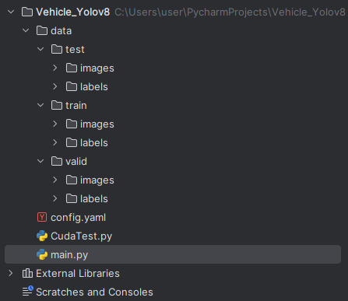

Figure 3.12 Folder structure of YOLOv8 PyCharm Project

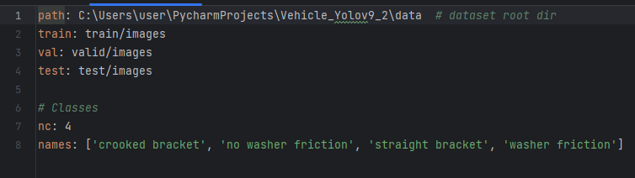

Figure 3.13 Codes for “config.yaml”

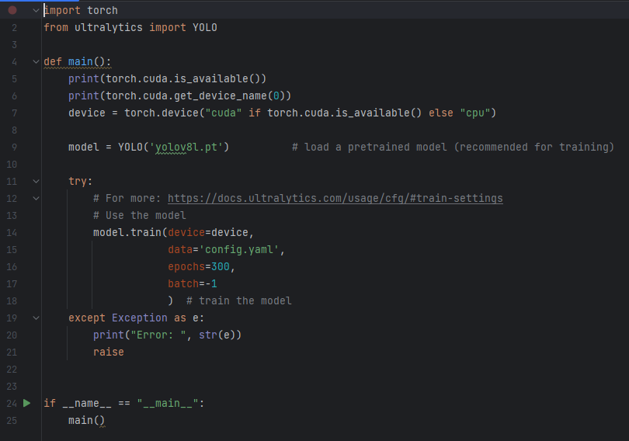

Figure 3.14 Codes for main.py

## YOLOv9c

For YOLOv9, it is pretty much the same procedure as in YOLOv8. There are only two different things we need to do which is to modified the file path in “config.yaml” file and the code in “main.py” file as shown in figure 3.15 and figure 3.16.

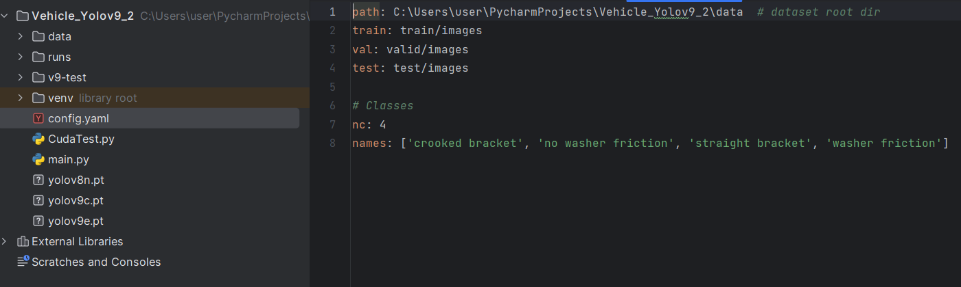

Figure 3.15 Code in “config.yaml” for YOLOv9

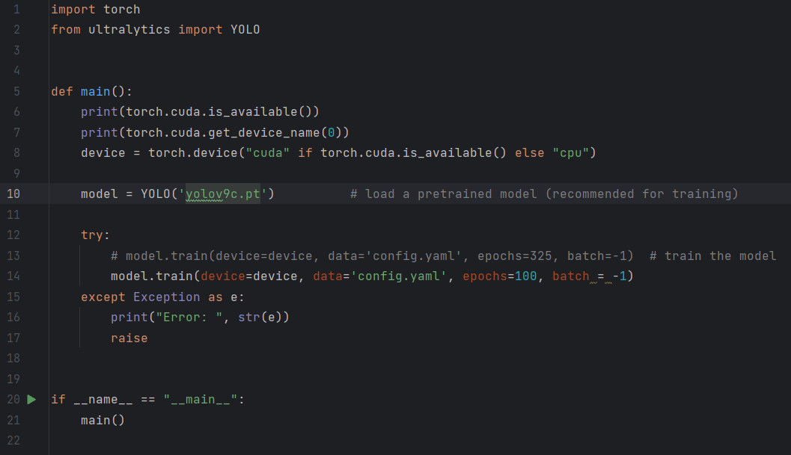

Figure 3.16 Codes in “main.py” for YOLOv9

# Raspberry Pi Zero WH

Raspberry Pi Zero WH is a small single-board computer that we will used to communicate with the camera and the graphical user-interface (GUI). Once it received signal from the user interface, it will asked the camera to snap a picture and send it back to the user interface for further processing.

There are a few goals for Raspberry Pi Zero WH as follows:

1. Raspberry Pi operating system setup
2. Testing of Hikvision webcam operating from the OS system of Pi Zero WH
3. Writing of codes for the Pi Zero WH to receive signal from user interface and send image back to user interface.
4. Writing service file in system to always run the python file every time Pi Zero WH is turned on.

## Components Requirements

Raspberry Pi Zero WH (Wireless with Header)

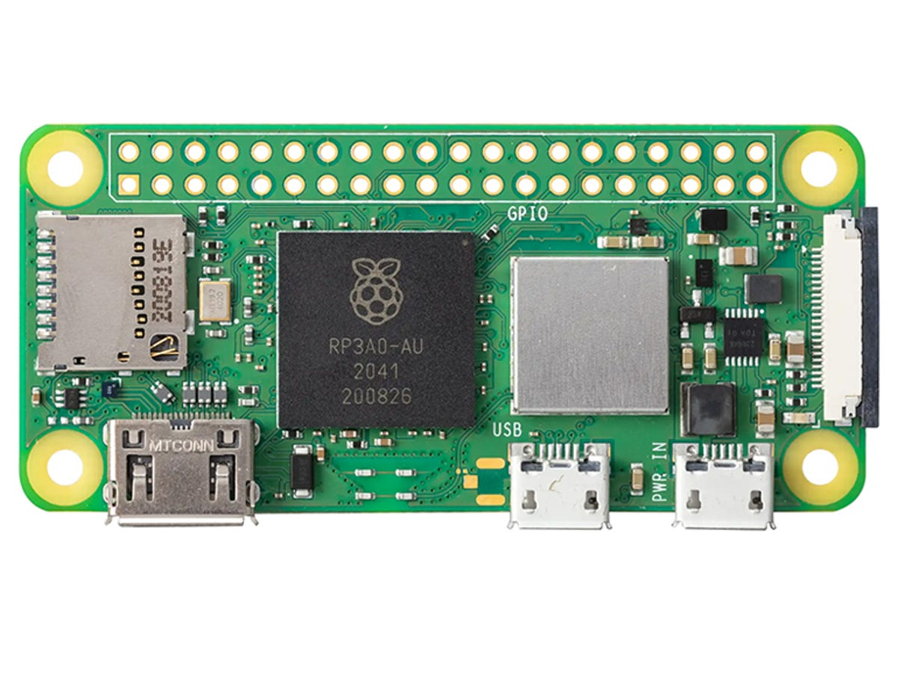

Figure 4.1 Raspberry Pi Zero WH (Wireless with Header)

Table 4.1 Specifications of Raspberry Pi Zero WH (Wireless with Header)

|  |  |
| --- | --- |
| **Specification** | **Detail** |
| Processor | Single-core CPU |
| Memory | 512MB RAM |
| Connectivity | Wi-Fi 802.11 b/g/n, Bluetooth 4.1, BLE (Bluetooth Low Energy) |
| I/O ports | Mini HDMI, USB On-The-Go port, Micro USB power |
| GPIO | 40-pin GPIO header pre-soldered |

Hikvision 1080P HD Webcam DS-U02

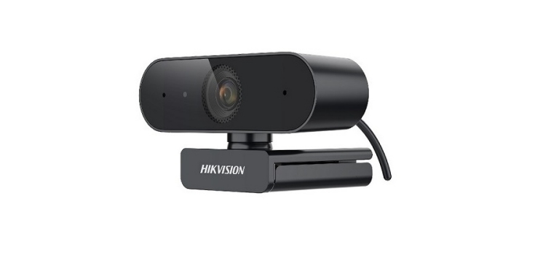

Figure 4.2 HIKVISION Web Camera

Table 4.2 Specifications of Hikvision Web Camera

|  |  |
| --- | --- |
| **Specification** | **Detail** |
| Frane Rate | 30 fps |
| Resolution | 1080P (1920 x 1080) |
| Field of View | 95° |
| Connection Interface | USB 2.0 |
| Mounting Options | Universal clip for laptops, LCDs, or monitors |

RPi Approved MakerDisk C10 A1 uSD with RPi OS - 32GB

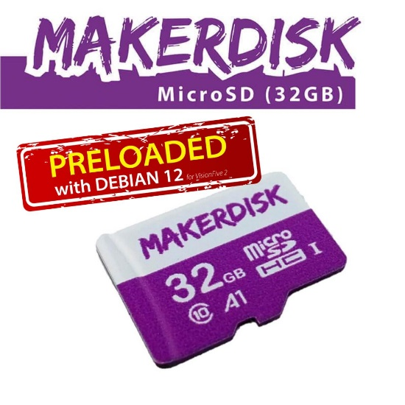

Figure 4.3 RPi Approved MakerDisk C10 A1 uSD with RPi OS - 32GB

Table 4.3 Specifications of Jetson NANO USB Wireless Network Dongle

|  |  |
| --- | --- |
| **Specification** | **Detail** |
| Capacity | 32GB |
| Class | Class 10, A1 rating for faster application performance |
| Preloaded | Comes with Raspberry Pi OS pre-installed |
| Compatibility | Designed for use with Raspberry Pi devices |

Official RPi 12.5W PSU microB UK Plug

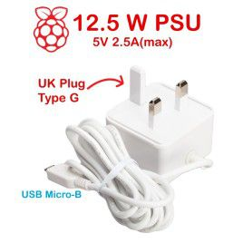

Figure 4.4 Official RPi 12.5W PSU microB UK Plug

Table 4.4 Specifications of Official RPi 12.5W PSU microB UK Plug

|  |  |
| --- | --- |
| **Specification** | **Detail** |
| Output | 5.1V / 2.5A DC output |
| Connector | Micro USB B |
| Power | 12.5W, suitable for powering Raspberry Pi devices |
| Plug type | UK plug with fuse |

Mini HDMI Adapter

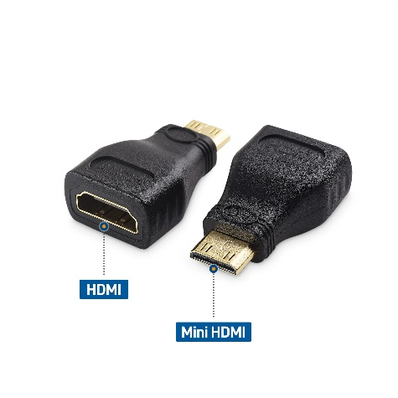

Figure 4.5 Mini HDMI Adapter

Table 4.5 Specifications of Mini HDMI Adapter

|  |  |
| --- | --- |
| **Specification** | **Detail** |
| Interface | Converts from mini HDMI to standard HDMI |
| Compatibility | Designed for devices with mini HDMI ports, like Raspberry Pi  Zero |

Official RPi micro USB adapter

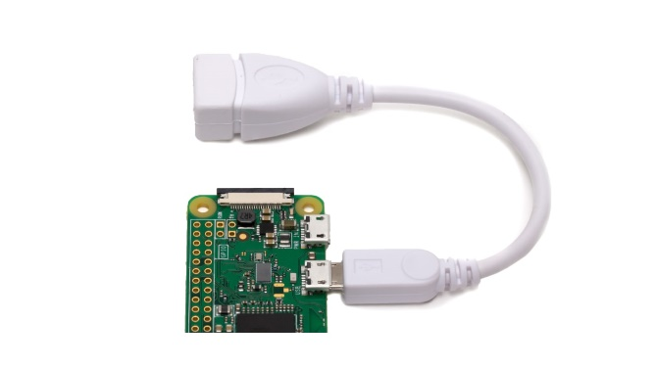

Figure 4.6 Official RPi micro USB adapter

Table 4.6 Specifications of Official RPi micro USB adapter

|  |  |
| --- | --- |
| **Specification** | **Detail** |
| Type | Micro USB to USB adapter |
| Functionality | Enables connection of USB devices to micro USB ports |

USB2.0 Cytron microSD Card Reader/Writer Adapter

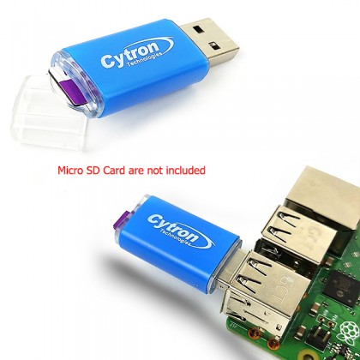

Figure 4.7 USB2.0 Cytron microSD Card Reader/Writer Adapter

Table 4.7 Specifications of USB2.0 Cytron microSD Card Reader/Writer Adapter

|  |  |
| --- | --- |
| **Specification** | **Detail** |
| Interface | USB 2.0 for fast data transfer |
| Compatibility | Designed for reading and writing to microSD cards |

## Setup

To setup Pi Zero WH with Raspberry Pi OS system, the first thing we need to do is to install Raspberry Pi Imager from its official website [5] and run the Raspberry Pi Imager until the window pop-up as shown in figure 4.8. The second thing we need to do is to insert the SD card into the microSD USB card reader and plug it into our laptop. We have to format the SD card before we install the Raspberry Pi OS system inside because it might cause some issue or errors if we did not format it.

For the “CHOOSE DEVICE” option, we have to select Raspberry Pi Zero WH from it and select “Erase” from the “CHOOSE OS” option then select our SD card from the “CHOOSE STORAGE” option, press Next and wait for the process to completed.

After the process is completed, eject and plug in back the SD card reader then this time we pick Raspberry Pi OS (32-bit) from the “CHOOSE OS” option then press Next. If there is a pop-window shown, we can select the edit settings to set our username, password, Wi-Fi and other configurations as shown in figure 4.9. After that, just wait for the process to complete and we will have our operating system installed in the SD card.

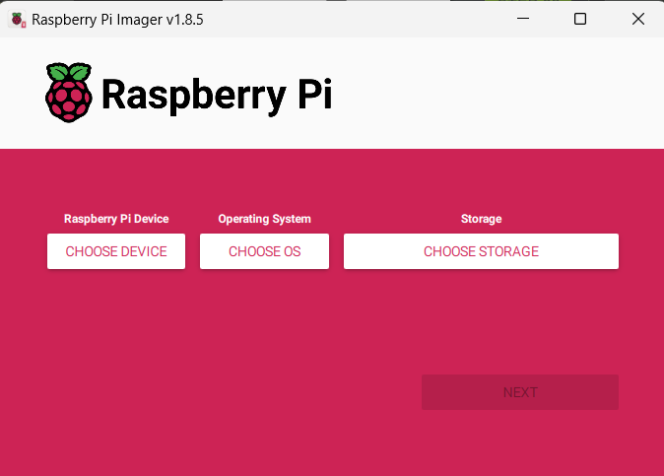

Figure 4.8 Raspberry Pi Imager pop-up window

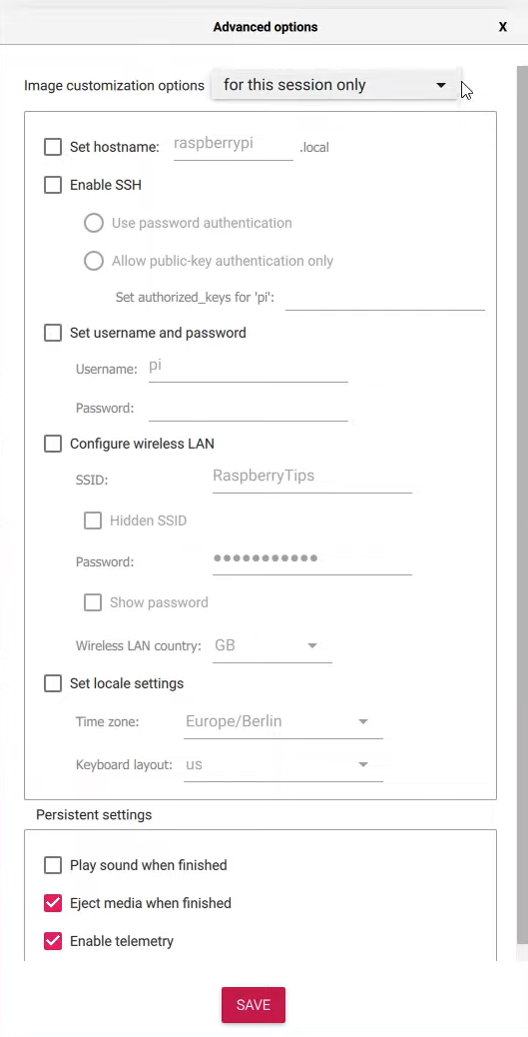

Figure 4.9 Advanced options for the configurations before setting up OS system

After the operating system has been write into the SD card, we can insert the SD card into our Pi Zero WH. After that, we are going to connect the mini HDMI port of Raspberry Pi Zero WH as shown in figure 4.11 to a monitor with the help of the mini-HDMI adapter and HDMI cable. After plugging in the Pi Zero WH with a screen and turn the Raspberry Pi Zero WH on, there should be a Raspberry Pi logo screen displayed it out as shown in figure 4.10 then it means we successfully setup the OS system in Pi Zero WH.

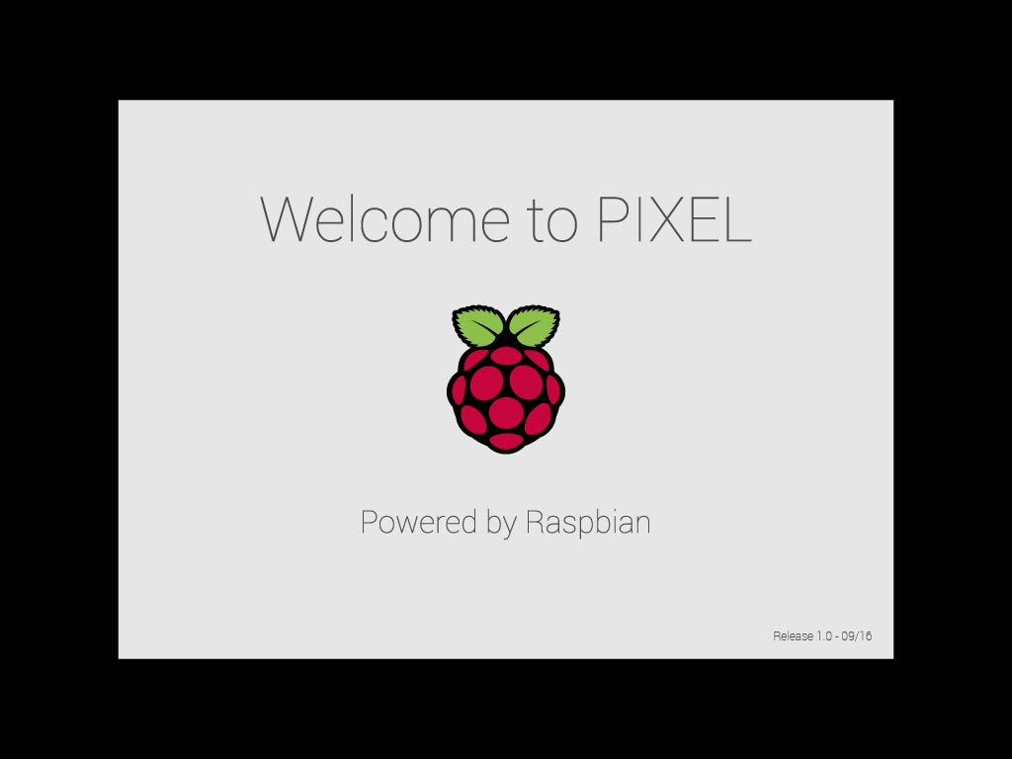

Figure 4.10 Boot screen of Raspberry Pi Zero WH

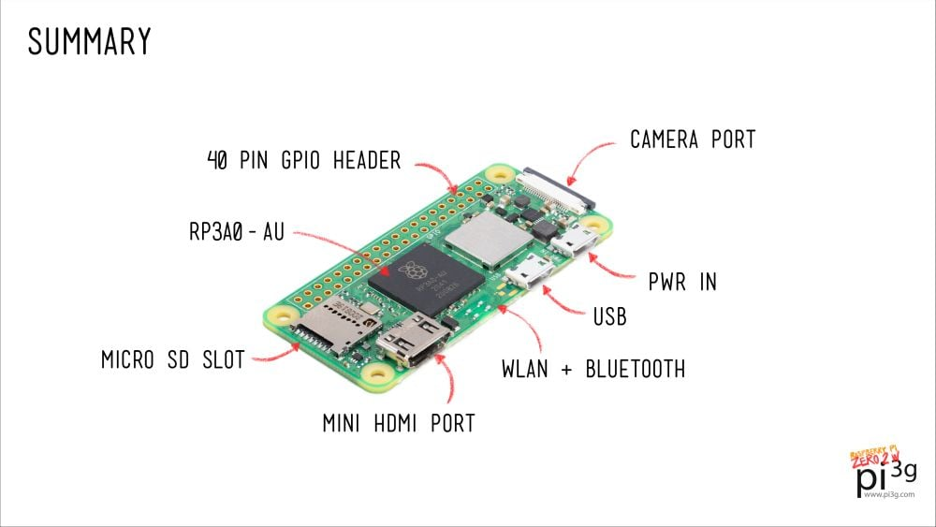

Figure 4.11 Raspberry Pi Zero ports

After that, we can use a micro-USB adapter to connect the Pi Zero WH with our mouse. We must use a Bluetooth connection mouse and keyboard because there is only one micro-USB port unless we found an adaptable multiple USB port adapter to connect with the micro-USB adapter without crashing the system. After connecting with the Bluetooth mouse and keyboard, we must switch off the Raspberry Pi Zero and connect the Hikvision webcam through the micro-USB adapter to our Pi Zero WH before turning it on again, the connection should look like figure 4.12.

Reminder:

1. Always plug in or connect the webcam to the Raspberry Pi Zero WH before switching it on because the board will be unable to retrieve the footage from the webcam even though there might be a displayed showing it is connected through the specific number of ports.
2. Always connect the Raspberry Pi Zero WH to a monitor before switching it on unless we do not need to use the monitor because the monitor will not display the screen of the operating system.
3. Make sure that the Raspberry Pi Zero WH is connected to one specific WIFI, preferable data hotspot and remember the IP address for the purpose of next few sections.

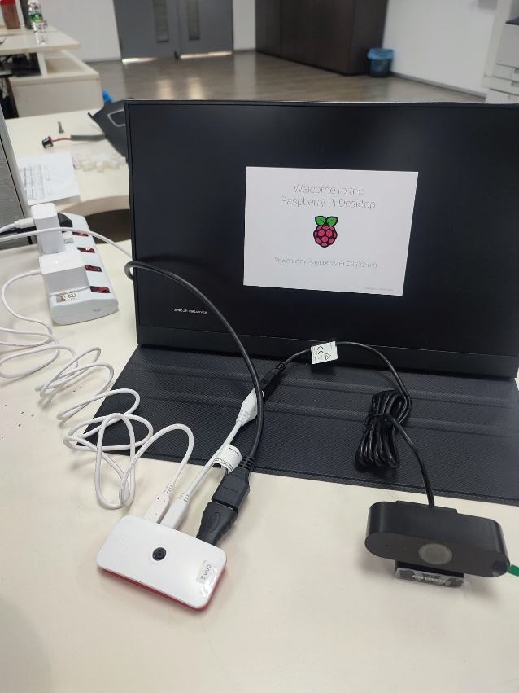

Figure 4.12 Connections of Raspberry Pi Zero WH with webcam and monitor

*Hikvision Webcam Testing*

After the connection of the Raspberry Pi Zero WH with the monitor and the Hikvision webcam, we can begin by testing the webcam first with the guidance of a video [6] (beginning with 5:50 until 6:30). The only difference between our method and the video is that after we type the command “lsusb”, we should follow the device number and select the device name based on that number.

For instance, figure 4.13 is the output of the command “lsusb” which shows that the webcam connected is on “Device 002” meaning that it is connector to port 2. Then we open the VLC Media Player and select the “Open Capture Device” from the “Media” option on the tools bar, we select the device name based on the output we obtained from “lsusb” which we select “/dev/video2” as shown in figure 4.14 and we play the video. We should get the video footage after loading as shown in figure 4.15, then we can begin to design our codes.

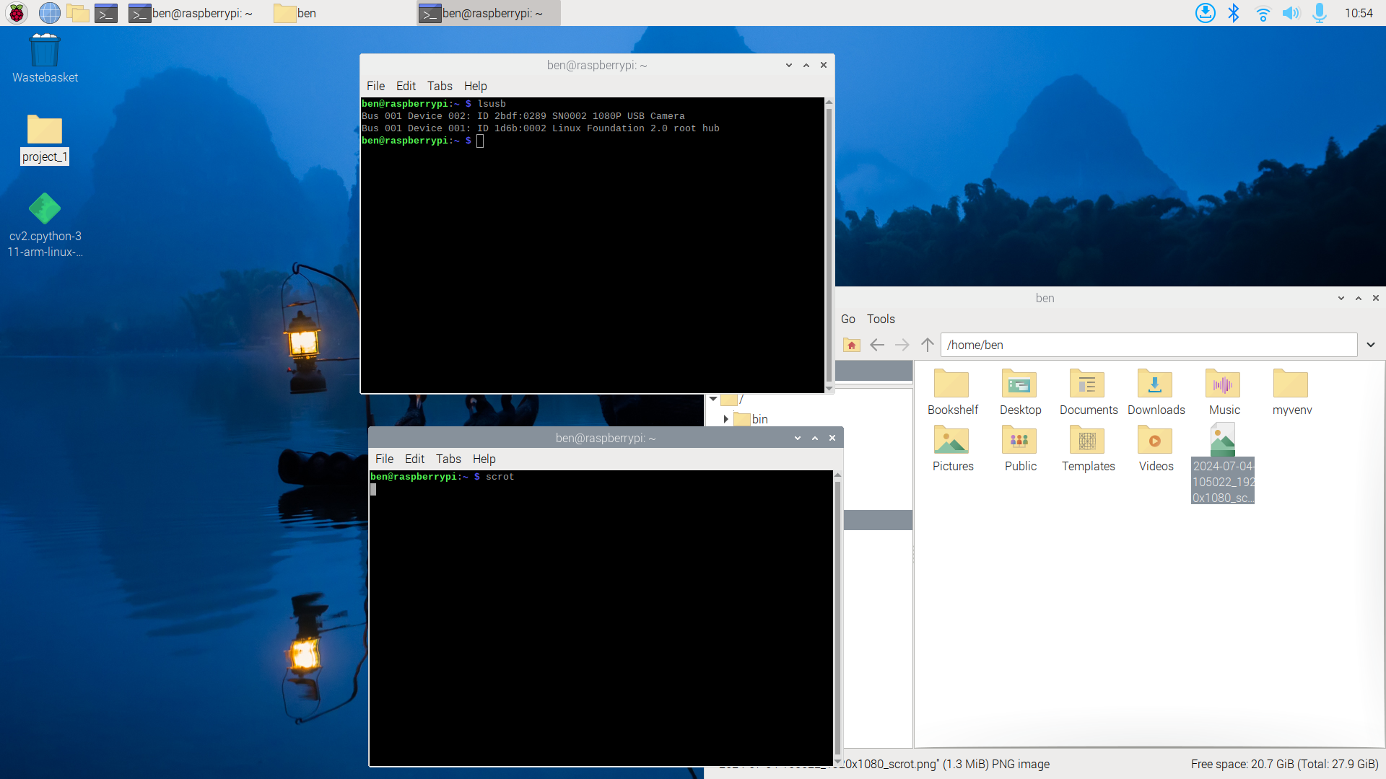

Figure 4.13 output of command “lsusb”

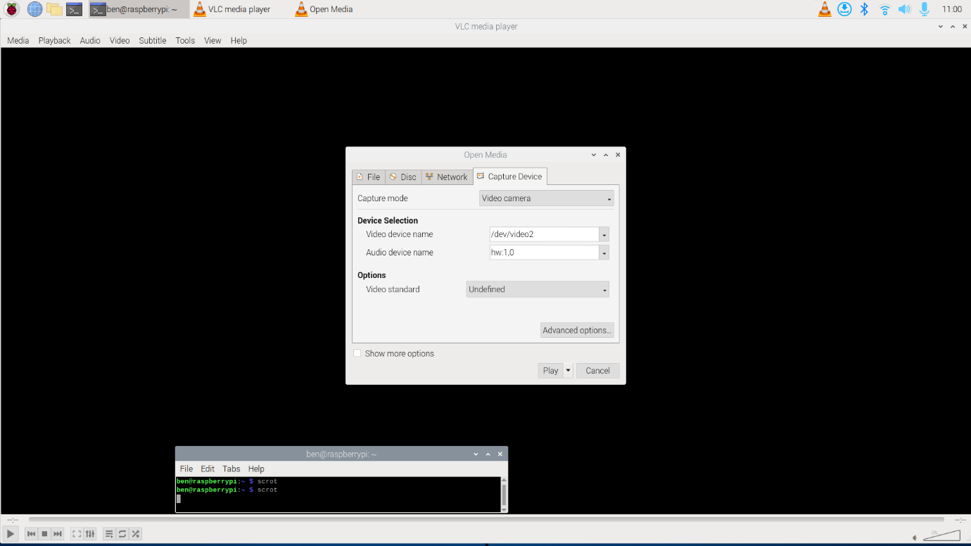

Figure 4.14 VLC player capture device

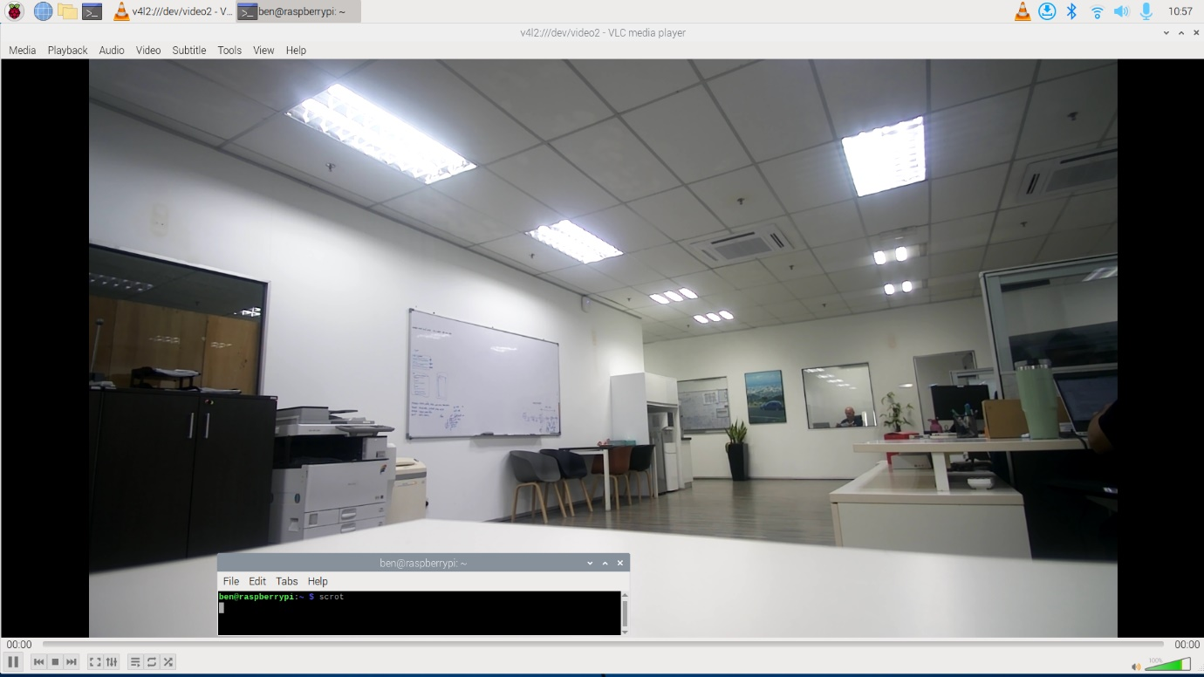

Figure 4.15 output of webcam testing

## Signal Communication Codes

*Environment and Libraries Installation*

We need to designed a code that allows the Pi Zero WH to be ready for receiving signal coming from the GUI and take picture once it receives signal then send the picture back to a server for the GUI to retrieve it. First, we have to create a virtual environment and install the necessary libraries by following the steps in table 4.1.

Table 4.1 Create environments and install libraries

|  |  |  |
| --- | --- | --- |
| **Steps** | **Commands** | **Remarks** |
| 1 | sudo apt install python3-venv |  |
| 2 | python3 -m venv myenv |  |
| 3 | source myenv/bin/activate |  |
| 4 | pip install Flask |  |
| 5 | sudo apt-get install opencv-python |  |
| 6 | sudo apt install libcamera-apps |  |

*Codes for signal communication and take picture*

After we completed the steps in table 4.1, we create a folder named “project_1” in the “Desktop” folder according to the path as shown in figure 4.16 and we also create a folder name “picture” in the “project_1” folder. While “project_1” folder, we create a python file and open that file. We type all the codes as shown in figure 4.17 with two functions which is to receive signal to ask the camera to take picture and send the image along with some messages back to the server.

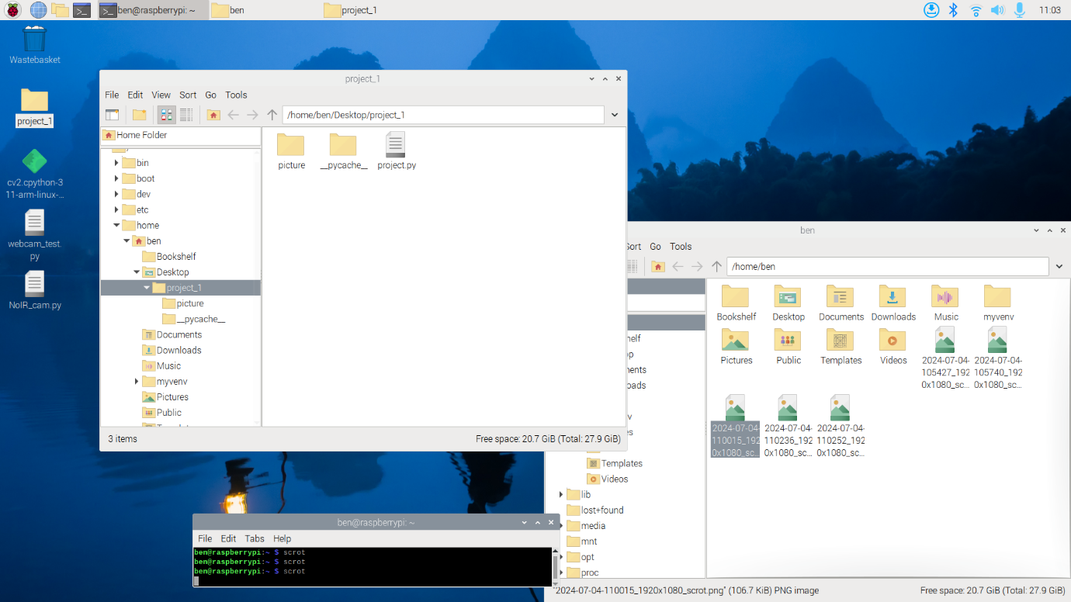

Figure 4.16 Folder structure and directory

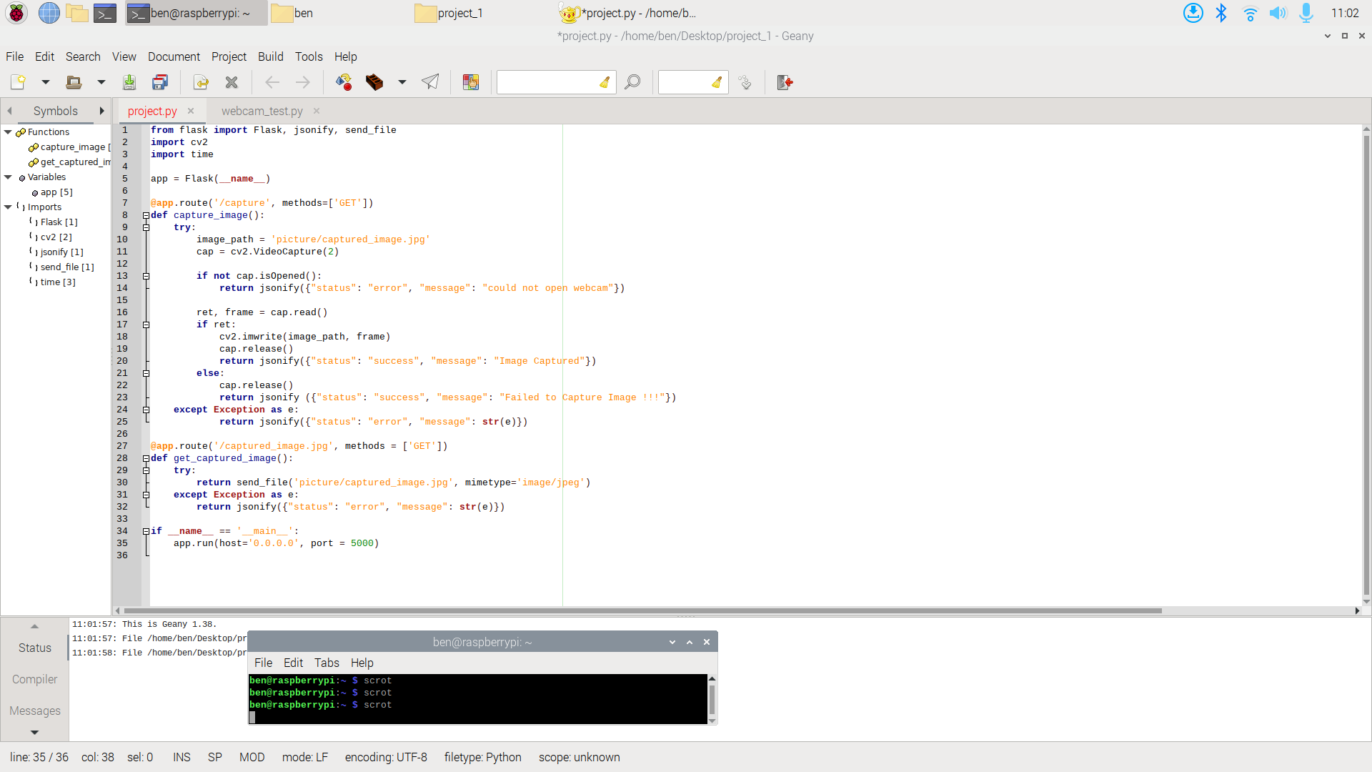

Figure 4.17 Codes for Pi Zero WH

*Codes for system to run python script every time when switched on*

If we run the “project_1” python file and obtained the output which give us an URL link with IP address and port numbers on it (port number is 5000 based on figure 4.17) like “http://192.168.217.201:5000/”, it means that the server has been active. Now the issue is we want the Pi Zero WH to run the “project_1” python script automatically every time we switch on the Pi Zero WH without accessing into the operating system and run manually. We can solve this issue by creating a service file in the operating system and start the service file, the service file will run every time the Pi Zero WH has been switched on and we designed some codes in the service file to launch the “project_1” python file so that the python file will be executed every time. We can follow the steps in table 4.2.

Table 4.2 Steps for adding configuration to the service file

|  |  |  |
| --- | --- | --- |
| **Steps** | **Commands** | **Remarks** |
| 1 | sudo nano /etc/systemd/system/flask_server.service |  |
| 2 | [Unit]  Description=Flask Server for Camera Capture  After=network.target  [Service]  ExecStart=/usr/bin/python3 /home/pi/app.py  WorkingDirectory=/home/pi/  StandardOutput=inherit  StandardError=inherit  Restart=always  User=pi  [Install]  WantedBy=multi-user.target | Type the following codes inside  Ctrl + x to exit then press Y then press enter |
| 3 | sudo systemctl enable flask_server.service |  |
| 4 | sudo systemctl start flask_server.service |  |
| 5 | sudo systemctl status flask_server.service |  |

*Take Note*

1. The Pi Zero WH must always connect to one WIFI or data hotspot due to different IP addresses will occur causing us to have to access into the operating system to find what is the new URL IP address link. Furthermore, remember the IP address.
2. For the second camera, all the steps is the same, the only different is we have to change the port number and cannot put port number 5000 same as figure 4.17 for the first camera, this will interrupt each other.

# Jetson Orin Nano

Jetson Orin Nano is a single-board computer that we will be using as a platform for defect inspection, this is the place where we implement trained models and create graphical user interface along with database.

There are a few goals for Jetson Orin Nano as follows:

1. Setting up of Jetson Orin Nano through SDK manager
2. PyCharm installation in Jetson Orin Nano
3. Installation and activation of PyTorch with CUDA support
4. Installation of MySQL and PhpMyAdmin and create database
5. Website development with implementation of trained models and database
6. Testing of sending signal to webcam and retrieve the picture taken by the webcam
7. Full design of website development with vehicle status

## Setup Using SDK Manager

To setup Jetson Orin Nano, there are two ways of doing it which is either with the help of SDK manger [7] or shell script [8] but there is a requirement for running both which is it needs Linux system to run the program to setup Jetson Orin Nano. Since SDK manger is much user friendly, we are going to use that to help us setup the Jetson so we are going to need a Linux based laptop to install SDK manger, **virtual machine** is **unavailable** because it cannot flash Jetson board due to the USB plug connected to it. Personal guess would be the port from the laptop does not directly link to virtual machines which might be the reason causing it to fail when we flash our Jetson from virtual machine Linux. There are two ways to use SDK manager which are either we used another **Linux based laptop** or we **dual boot** our own laptop to have both Windows and Linux OS system in it.

After we have our Linux system up and running, we can start installing SDK manager from NVIDIA website [9] and run the application. Once the installation is complete, it will ask us to login before starting the first step of setting up our Jetson board. After the login is completed, the first step page will pop out as illustrated in figure 5.1 and we can change the options if required. After we pressed continue, step 2 as shown in figure 5.2 allowed us to determine which Jetson software we are going to install and we can change the download folder if needed.

In step 3, there are two ways for us to setup the Jetson. If the Jetson has been flashed before with exist username and password, then we can used the automatic setup as shown in figure 5.3. If we are flashing the Jetson board for the first time, we can do the manual setup, select the necessary options for manual setup as shown in figure 5.4 then we connect the GPIO pin 9 and pin 10 together through a jumper as shown in figure 5.5 to force the Jetson to be in a recovery mode then we turned on the switch and plug the USB cable of Jetson to our device.

After the Jetson has been detected, we click flash then we wait until another pop-up window show up as shown in figure 5.6. After the window as shown in figure 5.6 has pop-up, we have configure the Jetson before proceeding to the next step. To do that, we have to used a HDMI cable to connect the Jetson board to a monitor or screen and we also need to plug in a keyboard and a mouse to the Jetson board for us to configure the Jetson. We just need to follow the instructions shown by the Jetson on the monitor until the Jetson reboot itself, the most important part is setting up an username and a password. After that, we can proceed we the SDK manager (figure 5.6) to insert the username and password that we just created in Jetson Linux and click install then process will run until step 4 which is completed. Finally, we have successfully setup our Jetson Orin Nano.

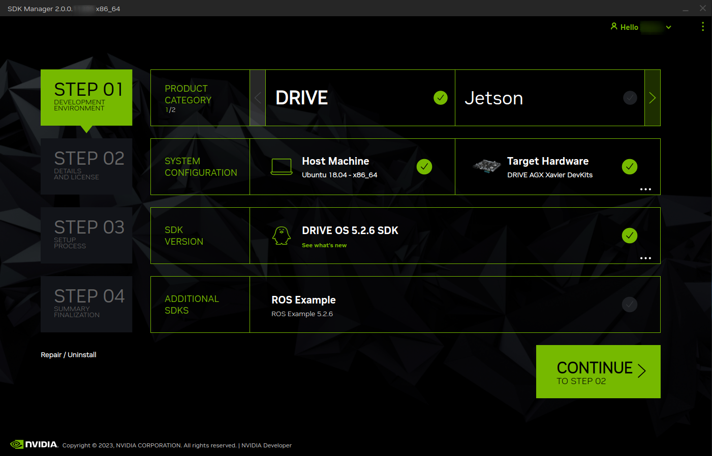

Figure 5.1 Step 1 of SDK manager

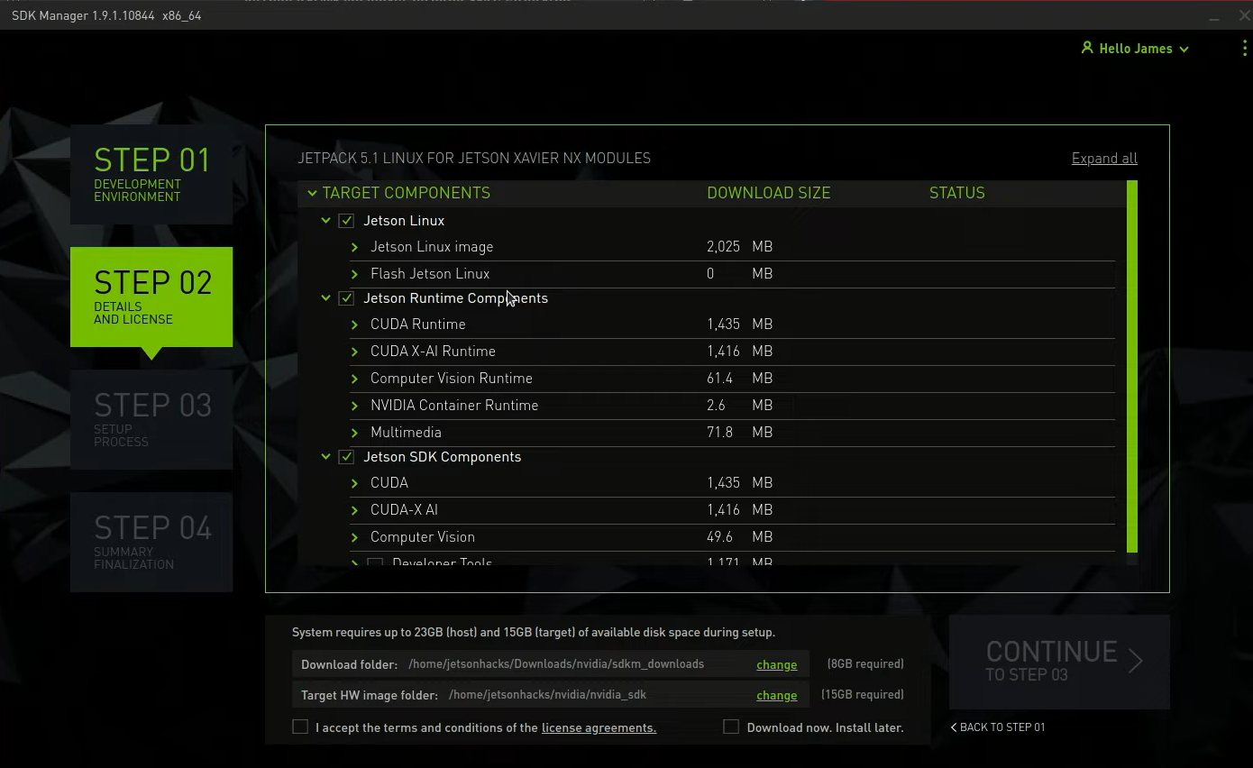

Figure 5.2 Step 2 of SDK manager

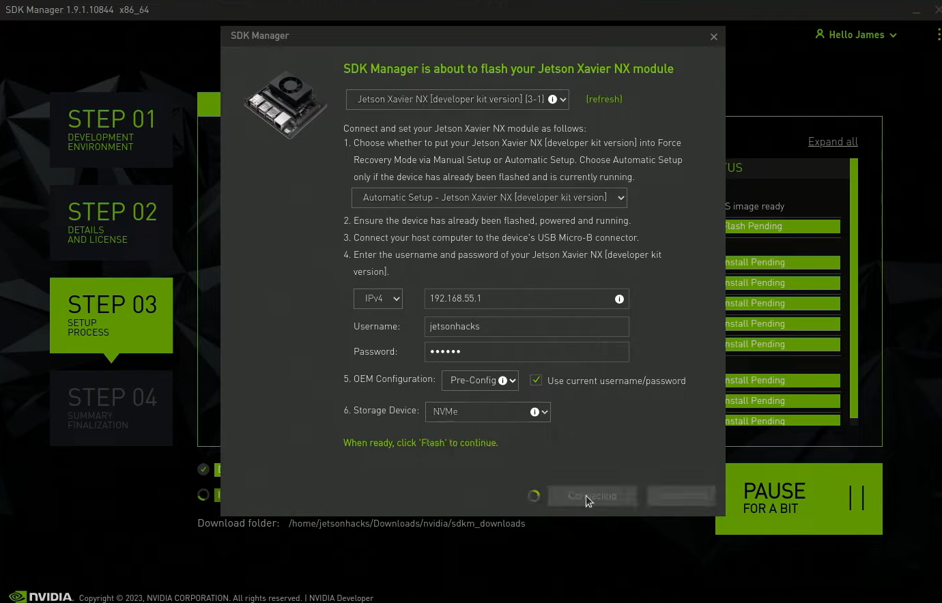

Figure 5.3 Automatic setup in step 3 of SDK manager

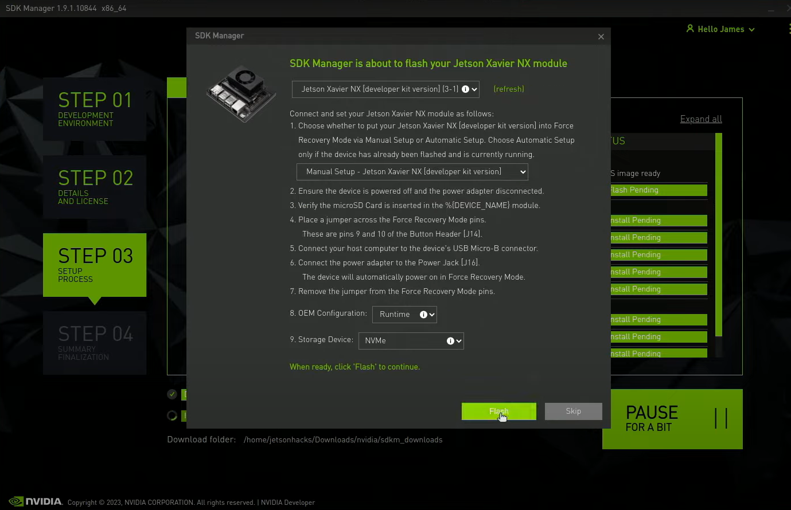

Figure 5.4 Manual setup in step 3 of SDK manager

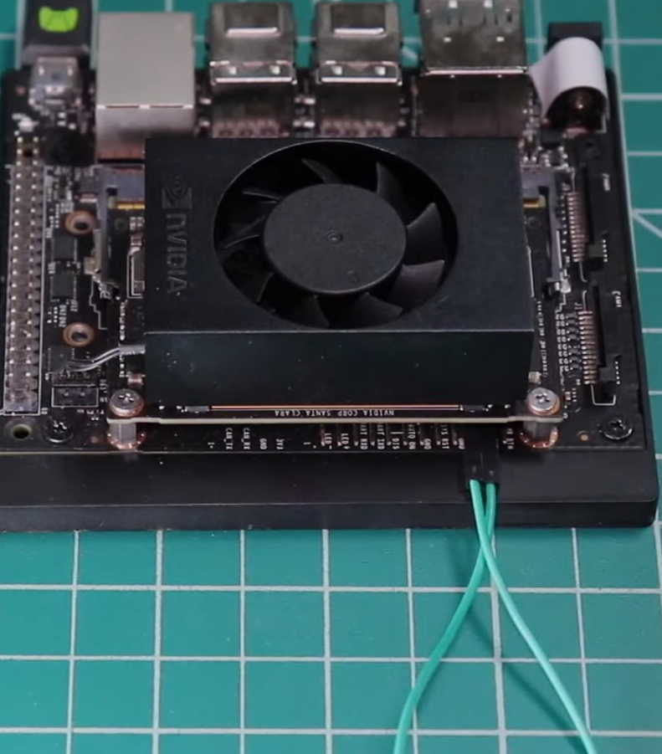

Figure 5.5 Connecting pins through jumper for force recovery mode

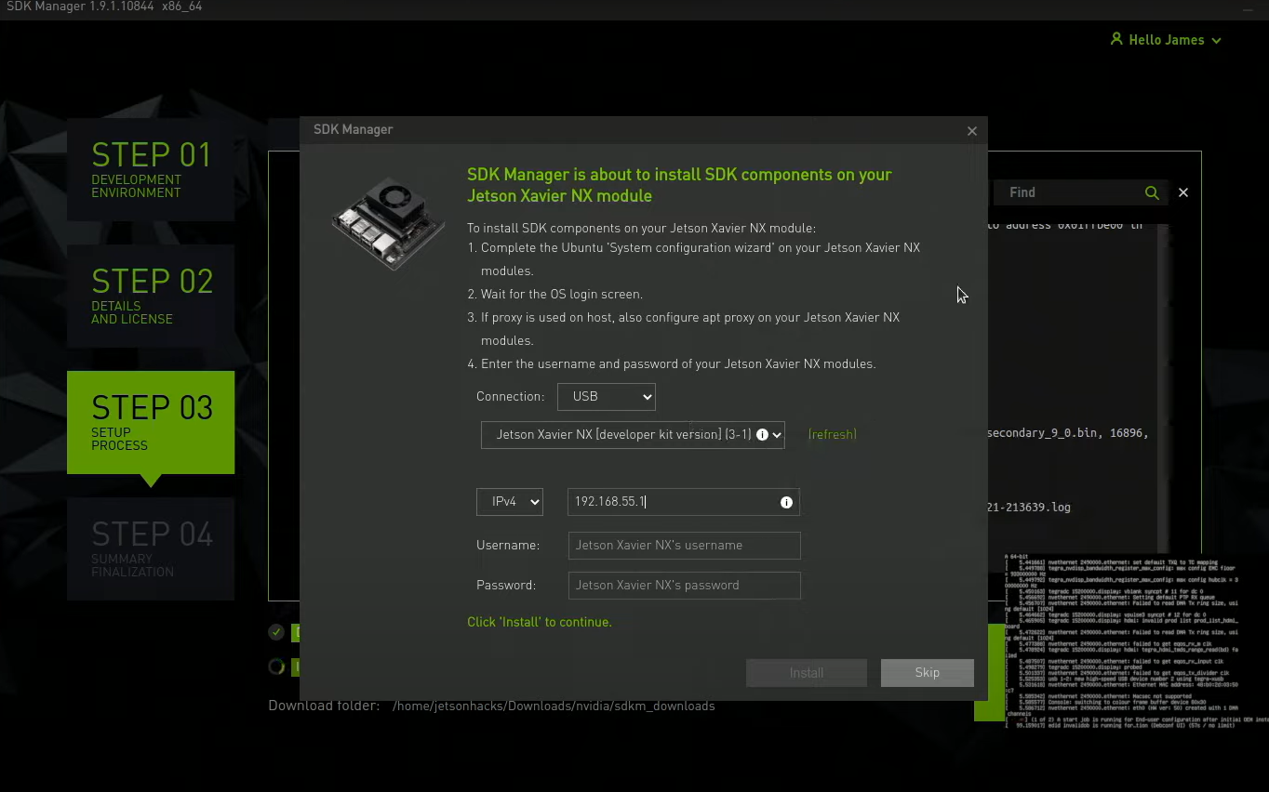

Figure 5.6 SDK components installation menu

## PyCharm Community Installation

After we have setup our Jetson Orin Nano, the first thing that we need to do is to install PyCharm Community because that is the platform for the user interface codes and also implementation of MySQL and deep learning mode. The installation of PyCharm Community is unlike any other regular installation due to its architecture, so we have to install it differently by installing from Pi-Apps [10].

Open the terminal from our Jetson and run the following command to install Pi-Apps:

“wget -qO- https://raw.githubusercontent.com/Botspot/pi-apps/master/install | bash”

After the installation is completed, open the Pi-Apps from the start menu and click on Programming category as shown in figure 5.7. In the programming category, scroll down until we find PyCharm CE then we click install as shown in figure 5.8. Finally, PyCharm CE has been installed and we can use it.

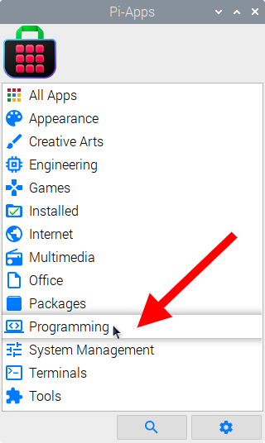

Figure 5.7 Categories from Pi-Apps

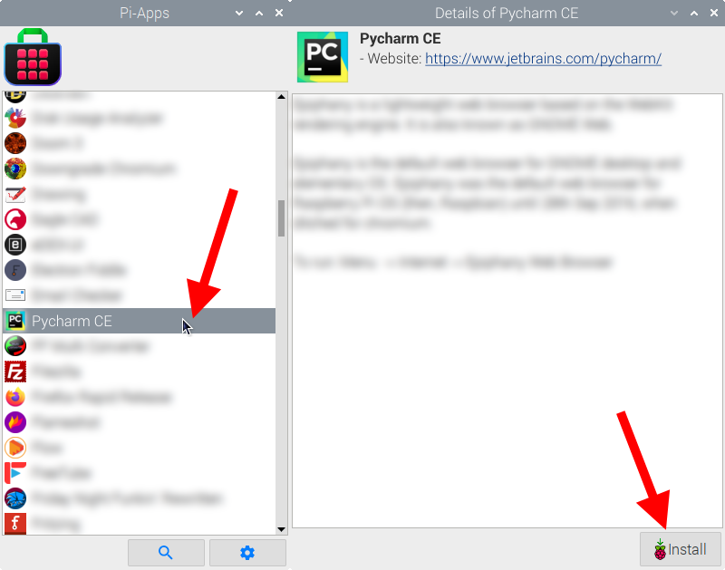

Figure 5.8 PyCharm CE from Programming category

## CUDA Installation

Before installing CUDA, we must check what CUDA version does the Jetson Orin Nano currently using. There are two methods which one of them we can run the following command in the terminal:

“nvcc –version”

The other method is by using jtop, we can install it according to the resource [11]. Let us assume that our Jetson Orin Nano currently using CUDA 12.4 and it is JetPack 6, then we have to install PyTorch version that is compatible with both of them which we can either refer it from NVIDIA developer forums [12] or from developer website for CUDA 12.4 [13]. We install the three files that we need according to figure 5.9, then we can create a Python project from PyCharm CE with the environment we desired then we open the terminal from the project in PyCharm CE and run the following command to move to the download folder:

“cd ~/Downloads”

In the download folder, we run the following three commands to install the PyTorch files:

“pip3 install torch-2.3.0-cp310-cp310-linux_aarch64.whl”

“pip3 install torchaudio-2.3.0+952ea74-cp310-cp310-linux_aarch64.whl”

“pip3 install torchvision-0.18.0a0+6043bc2-cp310-cp310-linux_aarch64.whl”

After the process is completed, we can create a python file from our project in PyCharm CE and type the following codes as shown in figure 5.10 to test and check the CUDA is activated or not.

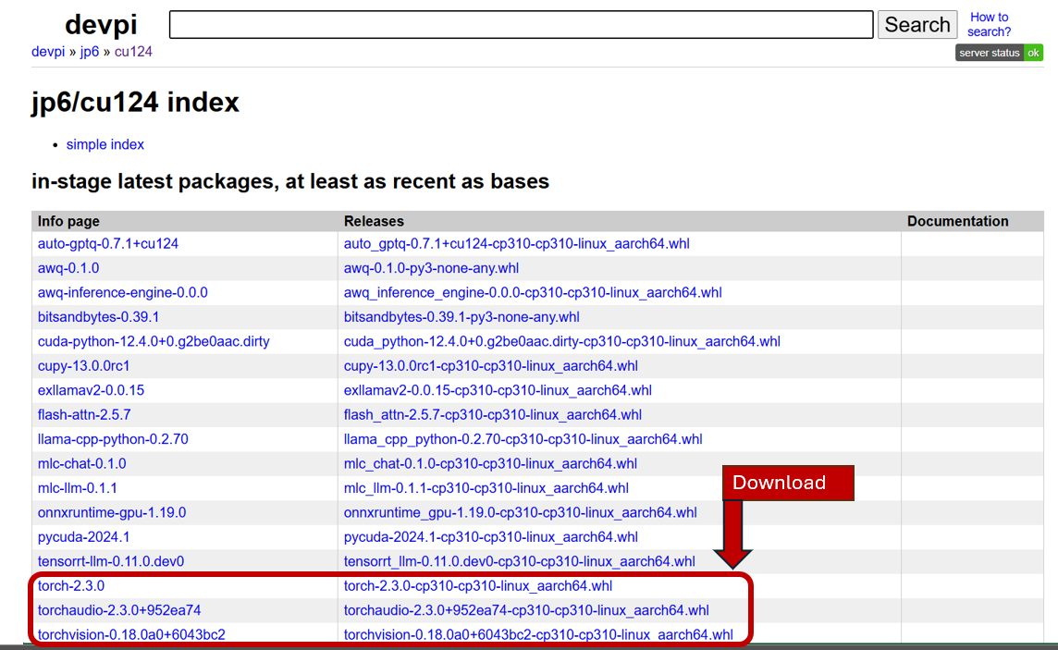

Figure 5.9 Installation of PyTorch files

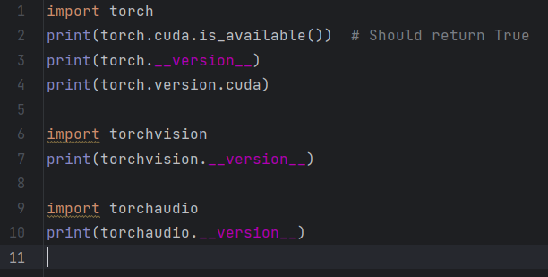

Figure 5.10 Codes to test PyTorch with CUDA 12.4 support

## MySQL & PhpMyAdmin Installation and Activation

Structured Query Language (SQL) is used to control and change databases in MySQL, it is an open-source relational database management system (RDBMS). MySQL is an important part of many web services, especially those that use the LAMP stack (Linux, Apache, MySQL, PHP/Python/Perl). It is known for being fast, scalable, and widely used. It can be used on multiple platforms, is good at managing big databases and a lot of users and can be used for anything from small websites to large enterprise applications.

PhpMyAdmin is a free, open-source web-based tool for handling MySQL databases through a graphical user interface (GUI). PhpMyAdmin makes it easier to do things like create and change databases and tables, run SQL queries and manage user rights, all without having to use command-line tools. It can be accessed through a web browser. It has tools for managing users, maintaining databases, and importing and exporting data. This makes it an accessible and easy-to-use option for both new and experienced MySQL database administrators.

We will be explaining about the installation of MySQL and PhpMyAdmin based on resource [14]. Take note that the username and id password has to follow on your own and we do not have to follow the steps 100%.

*MySQL*

This section explains about how we start from installing MySQL to creating our own user. The steps and explanation are tabulated in table 5.1, all we have to do is just follow the steps and paste the command in our terminal or linux.

Table 5.1 Steps for creating user in MySQL

|  |  |  |
| --- | --- | --- |
| **Steps** | **Command** | **Remarks** |
| 1 | sudo apt update |  |
| 2 | sudo apt install mysql-server | Type and enter Y for confirm installing |
| 3 | sudo mysql |  |
| 4 | alter user ‘root’@’localhost’ identified with mysql_native_pasword by ‘yourpassword’; | Change ‘yourpassword’ to preferred password |
| 5 | exit |  |
| 6 | mysql_secure_installation | Enter password from step 4  Follow the instruction and select prefer options  In our case:  no > yes > yes > yes > yes |
| 7 | mysql -u root -p | Enter password from step 4 |
| 8 | create database data1; | Change ‘data1 to preferred name |
| 9 | show schemas; | To see database it created or not |
| 10 | create user ‘abstract-programmer’@’localhost’ identified with mysql_native_password by ‘yourpassword2’; | Change ‘abstract-programmer’ and ‘yourpassword2’ to preferred username and password respectively. |
| 11 | use mysql |  |
| 12 | select user from user; | Check whether user is created |
| 13 | grant all on data1.* to ‘abstract-programmer’@’localhost’; | Change ‘data1’ and ‘abstract-programmer’ to database and username from step 8 and step 10 respectively. |
| 14 | exit |  |

*PhpMyAdmin and Apache*

The installation process for PhpMyAdmin is stated in table 5.2 below. After that we can head to PhpMyAdmin local webpage by this URL link <http://localhost/phpmyadmin> . The login page of PhpMyAdmin should pop out as in figure 5.11. We can login by entering the username and password we created, in our case are ‘abstract-programmer’ and ‘yourpassword2’ respectively.

After that, we can click the plus sign of our ‘data1’ which is the database we created then it will extend out. We can create our data table by clicking the new, then we can follow figure 5.12 to fill up the name and necessary slots with the information we need. In our project, we are going to need five data tables to store our data results due to the designs we are going to create later on which are ‘data_bulk_image’, ‘data_capture’, ‘data_image’, ‘data_video’ and ‘data_live’ as shown in figure 5.13.

Table 5.2 Installation process for PhpMyAdmin and Apache

|  |  |  |
| --- | --- | --- |
| **Steps** | **Commands** | **Remarks** |
| 1 | sudo apt install php | Press Y and enter for installation confirm |
| 2 | Sudo apt install phpmyadmin | Press Y and enter for installation confirm  Choose No  Choose Apache2 |
| 3 | sudo apt install apache2 |  |
| 4 | sudo systemctl start apache2 | Start apache2 |
| 5 | sudo systemctl enable apache2 | Start apache2 every time device boot |
| 6 | sudo systemctl status apache2 | Check whether apache2 is started |

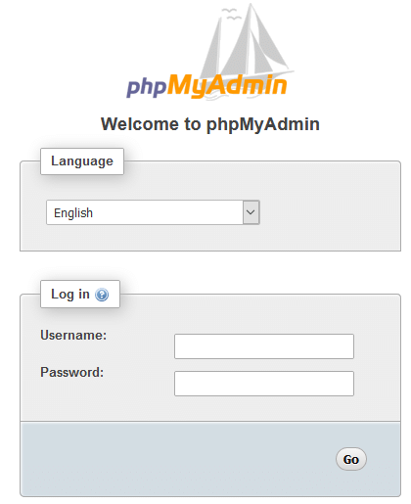

Figure 5.11 Login page of PhpMyAdmin

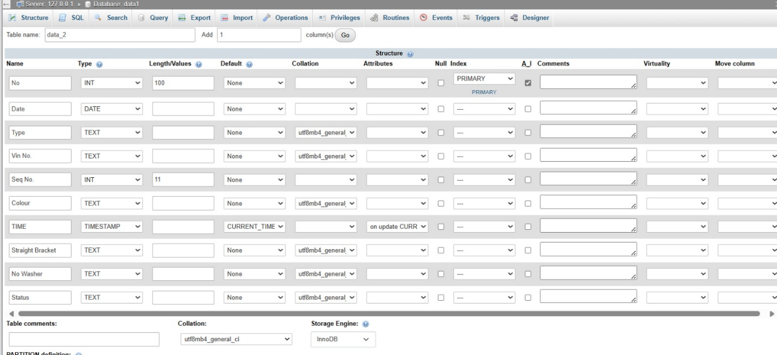

Figure 5.12 Table create in database ‘data1’

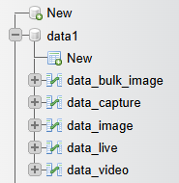

Figure 5.13 Data structure of database ‘data1’ PhpMyAdmin

## Website

Streamlit is an open-source Python tool that makes it easier to make web-based apps that are interactive for data science and machine learning projects. Developers and data scientists can quickly turn data scripts into shared web apps without having to know a lot about web development.

For our design, we are planning to create a total of five webpages. The first page will be the project explanation. The second page will be showing us the data results collected with bar chart displaying the vehicle results based on months, we can also insert certain parameters at the sidebar for data query. The third page will be for single image object detection where we can upload our image to do object detection and it also shows the data stored with a bar chart, we can also insert data for data storing in our database.

The fourth page is going to be a place where we can upload a bunch of images to do object detection and allow us to download the detected result images in a zip file. The fifth page will allow us to upload a video and do object detection on it. The sixth page will be the page where it will send a signal to the camera to take picture and send it back to do object detection which this is the main page we are going to use all the time as it is real-time wireless data transferring and there will be a pop out info telling us that whether the bolt is loose or not.

The last page is where we can open our webcam to test the real-time object detection.

Before we run all these files, we have to install all the necessary libraries as below:

1. pip install ultralytics
2. pip install streamlit
3. pip install pandas
4. pip install mysql.connector
5. pip install datetime
6. pip install matplotlib
7. pip install pillow

After that, we can start designing the webpages in our PyCharm project and the folder structure is illustrated in figure 5.14. The ‘CodeTest’ folder is where we store the code for testing purposes where the ‘images’ folder is where we stored our demo images. The ‘pages’ folder is where we stored the pages other than homepage and the ‘video’ folder is where we stored the demo videos.

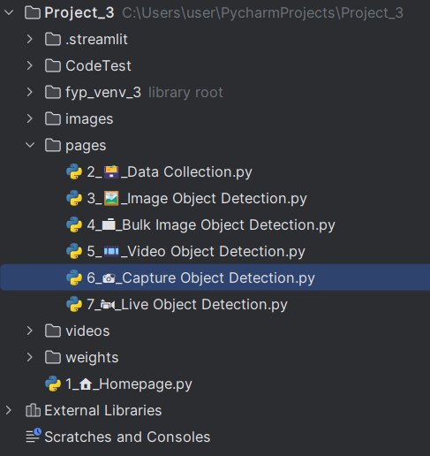

Figure 5.14 Folder structure of Streamlit project

The codes for each of the webpages are as below:

Appendix A: Homepage

Appendix B: Data Collection

Appendix C: Image Object Detection

Appendix D: Bulk Image Object Detection

Appendix E: Video Object Detection

Appendix F: Capture Object Detection

Appendix G: Live Object Detection

Take Note:

1. We have to know where we should change the database username, password, database name and data table name so that we can modify the codes to connect with our database properly.
2. Always remember where we should modify the IP address (Capture Object Detection) from the codes so that the graphical user interface is able to connect with Pi Zero WH.

# Limitation

1. Sudden change of IP Address

The fact that Pi Zero WH is connecting via data hotspot, the IP address that is provided from the data hotspot to the Pi Zero WH might change resulting in a disconnection between the Jetson Orin Nano to the Pi Zero WH. We will have to end up going inside the operating system of Pi Zero WH to check what is the new IP address numbers so that we can modify the IP address codes in Streamlit user interface codes of Jetson Orin Nano to build back the connection.

1. Data Management

After the defect inspection, the detected results and the information of the vehicle are stored by typing manually at the side bar with a submit button which sometime might be a hassle due to the time taken for typing. Furthermore, if we need to edit the data recorded, we have to go inside the PhpMyAdmin local host to edit the data.

1. Processing speed of Pi Zero WH

Due to the fact that Pi Zero WH is small and convenient along with minimal power consumption, the downside of it is that the processing speed of Pi Zero WH is very slow causing the time taken for it to received signal and take picture to send it back very long.

1. Localhost and Data hotspot

To access into the database, we have to connect to the same data hotspot which is a hassle when we are trying to access it from a long distance while there is a limit range of coverage for data hotspots. Furthermore, when doing the defect inspection, the Jetson Orin Nano and the Pi Zero WH have to be connected to the same data hotspot only for them to be able to communicate with each other which means the Jetson Orin Nano cannot be put far away from the Pi Zero WH and the data hotspot.

# Improvements

1. Fixed IP address

We need to establish a way to keep the IP address constant should it change without we notice. One way suggested is to assign a static IP address to the Raspberry Pi Zero WH which involves configuring the network settings to use a specific IP address rather than obtaining one dynamically from the DHCP server. Thus, we do not have to worry about the sudden change of IP address.

1. Automatic data management

Due to the fact that there are a lot of information regarding the vehicle like sequence number, VIN number, vehicle number, etc. All of the information can be obtained through the bar code by using the bar code scanner, so we might be able to create a graphical user interface which the user only have to scan the bar code of the vehicle and do the inspection straight without have to type in all the relevant information about the vehicle. Furthermore, we can also automatically saved the detected results after the inspection has been done by the model, meaning that we scan all the information regarding the vehicle and do the inspection lastly then the information regarding the vehicle and the detected results will automatically saved into the database. Lastly, we can add modification features to the graphical user interface to allow the user to edit or delete the data from the database.

1. Upgrading of Pi Zero WH

Due to Raspberry Pi Zero WH has a very low processing speed and power, it cause the program to react very slow meaning that it would took longer for the Raspberry Pi Zero WH to react to the signal sent and take picture using the webcam and send it back. A better suggestions other than Pi Zero WH are Raspberry Pi 4 Model B, Raspberry Pi 3 Model B+, Raspberry Pi 3 Model B, etc.

1. Deployment of the system

Consider deployment of the system will allow the inspection process be more convenient as we can undergo inspection system and access through database without connecting with the same data hotspot. Furthermore, we can have a better distance to do vehicle inspection without worrying about the coverage distance limit of data hotspot.

1. Upgrading camera

Considering upgrading camera to a higher resolution and can take pictures with much more clearance and sharpness can help the model to predict the defect parts more effectively. We can used the camera to obtain the dataset and used for training, after that we can used it for defect inspection too.

# Future Work Implementation

1. E-Traveller Card

Adding of E-Traveller card will allow the user to access the data in a more organized and structured way. Implementing the bar code scanner will allow the user to fill in the information of the vehicle like VIN number, sequence number, vehicle type, etc. easily by scanning the bar code only. All the information and detected results can be saved automatically while all the users can log into the database to view each of their particular task regarding the vehicle.

1. Implementation of other defect inspection

Considering adding other types of defect inspection would be beneficial as this will make the inspection time shorter without many workers meaning that it will increase the production rate and lower the cost. It would be best if all the inspection regarding underbody vehicle can be done through a model, this will give us a high efficiency in inspection process.

# Error Analysis

It is better to list down the errors that we encounter so that we will be able to solve it quickly in the future in case of facing the same error again. Due to the fact that the project is in a rush, we are unable to track back the error encountered, but it is better to start now to record the error encountered in the below.

1. For issue mysql connector "caching_sha2_password"

Solution: [15]

1. Issue :

>>> import torch Traceback (most recent call last): File "/home/vwpekan/.local/lib/python3.10/site-packages/torch/__init__.py", line 176, in _load_global_deps ctypes.CDLL(lib_path, mode=ctypes.RTLD_GLOBAL) File "/usr/lib/python3.10/ctypes/__init__.py", line 374, in __init__ self._handle = _dlopen(self._name, mode) OSError: libnvToolsExt.so.1: cannot open shared object file: No such file or directory During handling of the above exception, another exception occurred: Traceback (most recent call last): File "<stdin>", line 1, in <module> File "/home/vwpekan/.local/lib/python3.10/site-packages/torch/__init__.py", line 236, in <module> _load_global_deps() File "/home/vwpekan/.local/lib/python3.10/site-packages/torch/__init__.py", line 197, in _load_global_deps _preload_cuda_deps(lib_folder, lib_name) File "/home/vwpekan/.local/lib/python3.10/site-packages/torch/__init__.py", line 162, in _preload_cuda_deps raise ValueError(f"{lib_name} not found in the system path {sys.path}") ValueError: libcublas.so.*[0-9] not found in the system path ['', '/usr/lib/python310.zip', '/usr/lib/python3.10', '/usr/lib/python3.10/lib-dynload', '/home/vwpekan/.local/lib/python3.10/site-packages', '/usr/local/lib/python3.10/dist-packages', '/usr/lib/python3/dist-packages', '/usr/lib/python3.10/dist-packages']

Solution: [16]

“sudo apt-get update && sudo apt-get install nvidia-jetpack”

# Sources

[1] “CUDA GPUs - Compute Capability | NVIDIA Developer.” Accessed: Jul. 03, 2024. [Online]. Available: https://developer.nvidia.com/cuda-gpus#compute

[2] “CUDA Toolkit 12.1 Downloads | NVIDIA Developer.” Accessed: Jul. 03, 2024. [Online]. Available: https://developer.nvidia.com/cuda-12-1-0-download-archive

[3] “Start Locally | PyTorch.” Accessed: Jul. 03, 2024. [Online]. Available: https://pytorch.org/get-started/locally/

[4] “GitHub - WongKinYiu/yolov7: Implementation of paper - YOLOv7: Trainable bag-of-freebies sets new state-of-the-art for real-time object detectors.” Accessed: Jul. 03, 2024. [Online]. Available: https://github.com/WongKinYiu/yolov7

[5] “Raspberry Pi OS – Raspberry Pi.” Accessed: Jul. 03, 2024. [Online]. Available: https://www.raspberrypi.com/software/

[6] “(8) Raspberry Pi Zero 2 W with WebCam, and OpenCV Test - YouTube.” Accessed: Jul. 04, 2024. [Online]. Available: https://www.youtube.com/watch?v=Z2_zw0w_7IM&t=281s

[7] “(8) NVIDIA SDK Manager Tutorial: Installing Jetson Software Explained - YouTube.” Accessed: Jul. 04, 2024. [Online]. Available: https://www.youtube.com/watch?v=Ucg5Zqm9ZMk&t=612s

[8] “(8) Jetson Orin Nano Tutorial: SSD Install, Boot, and JetPack Setup - Full Guide! - YouTube.” Accessed: Jul. 04, 2024. [Online]. Available: https://www.youtube.com/watch?v=q4fGac-nrTI&t=380s

[9] “SDK Manager | NVIDIA Developer.” Accessed: Jul. 04, 2024. [Online]. Available: https://developer.nvidia.com/sdk-manager

[10] “Install Pycharm CE on Nvidia Jetson | Pi-Apps.” Accessed: Jul. 10, 2024. [Online]. Available: https://pi-apps.io/install-app/install-pycharm-ce-on-nvidia-jetson/

[11] “jtop: The Ultimate Tool for Monitoring NVIDIA Jetson Devices - JetsonHacks.” Accessed: Jul. 10, 2024. [Online]. Available: https://jetsonhacks.com/2023/02/07/jtop-the-ultimate-tool-for-monitoring-nvidia-jetson-devices/

[12] “PyTorch for Jetson - Jetson & Embedded Systems / Announcements - NVIDIA Developer Forums.” Accessed: Jul. 10, 2024. [Online]. Available: https://forums.developer.nvidia.com/t/pytorch-for-jetson/72048

[13] “jp6/cu124 index.” Accessed: Jul. 10, 2024. [Online]. Available: http://jetson.webredirect.org/jp6/cu124

[14] “(19) How to install mysql and phpmyadmin on ubuntu 22.04 - YouTube.” Accessed: Jul. 10, 2024. [Online]. Available: https://www.youtube.com/watch?v=Cmdrb420NNw&t=285s

[15] “(19) How to fix Authentication plugin ‘caching_sha2_password’ is not supported error? - YouTube.” Accessed: Jul. 10, 2024. [Online]. Available: https://www.youtube.com/watch?v=F6b36EdjrF8

[16] “Orin Pytorch/CUDA issue - Jetson & Embedded Systems / Jetson Orin NX - NVIDIA Developer Forums.” Accessed: Jul. 11, 2024. [Online]. Available: https://forums.developer.nvidia.com/t/orin-pytorch-cuda-issue/262858

# Appendix

Appendix A: Homepage

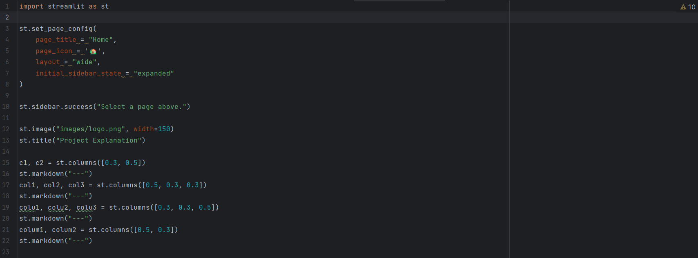

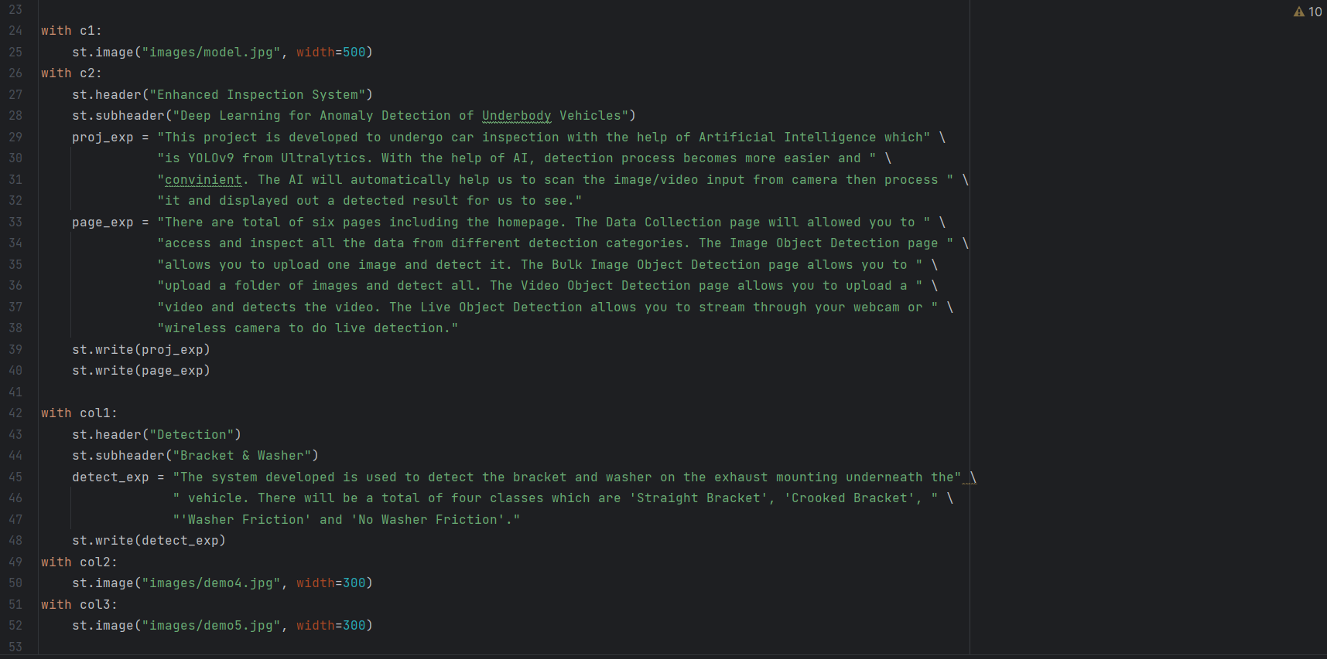

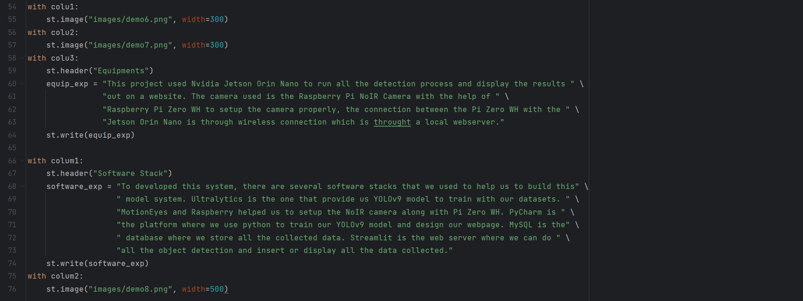

Appendix B: Data Collection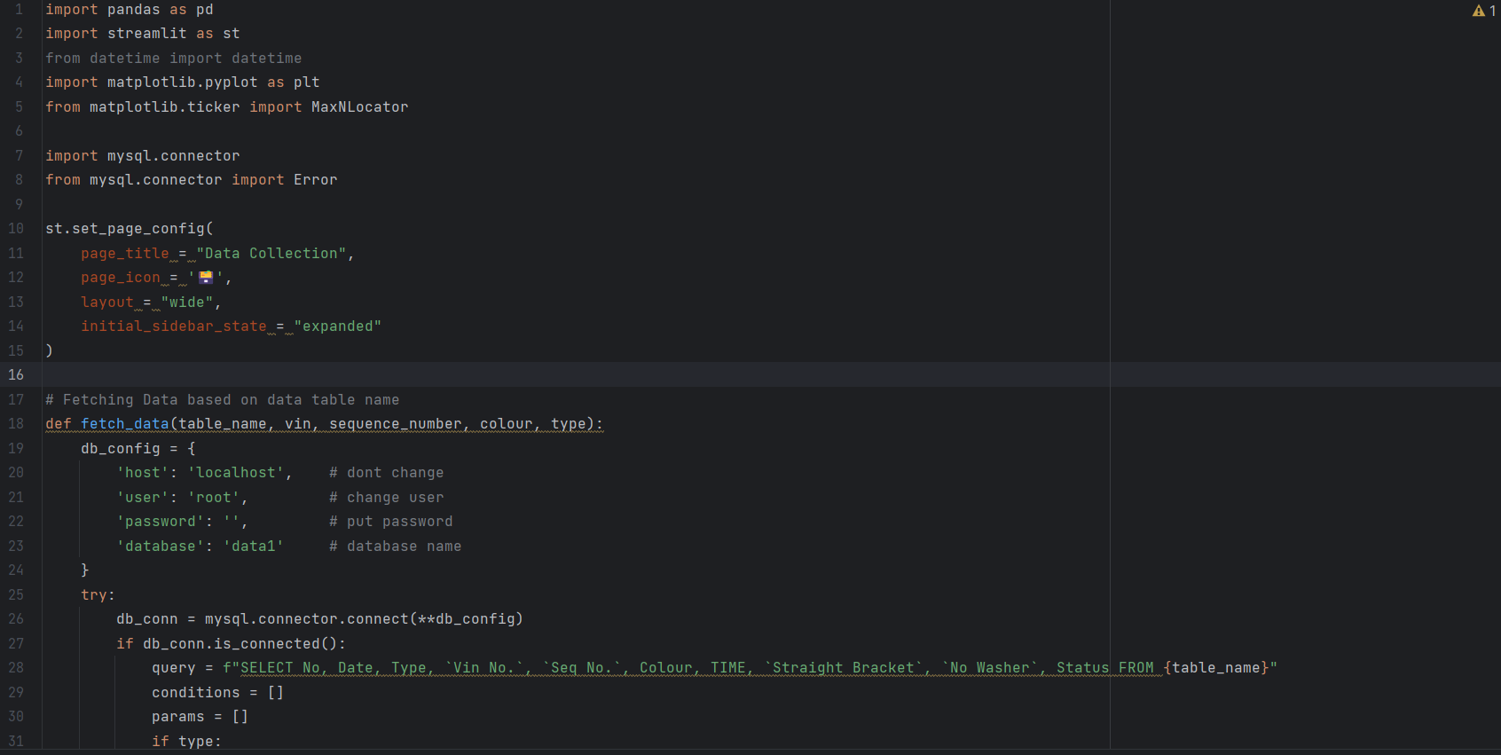

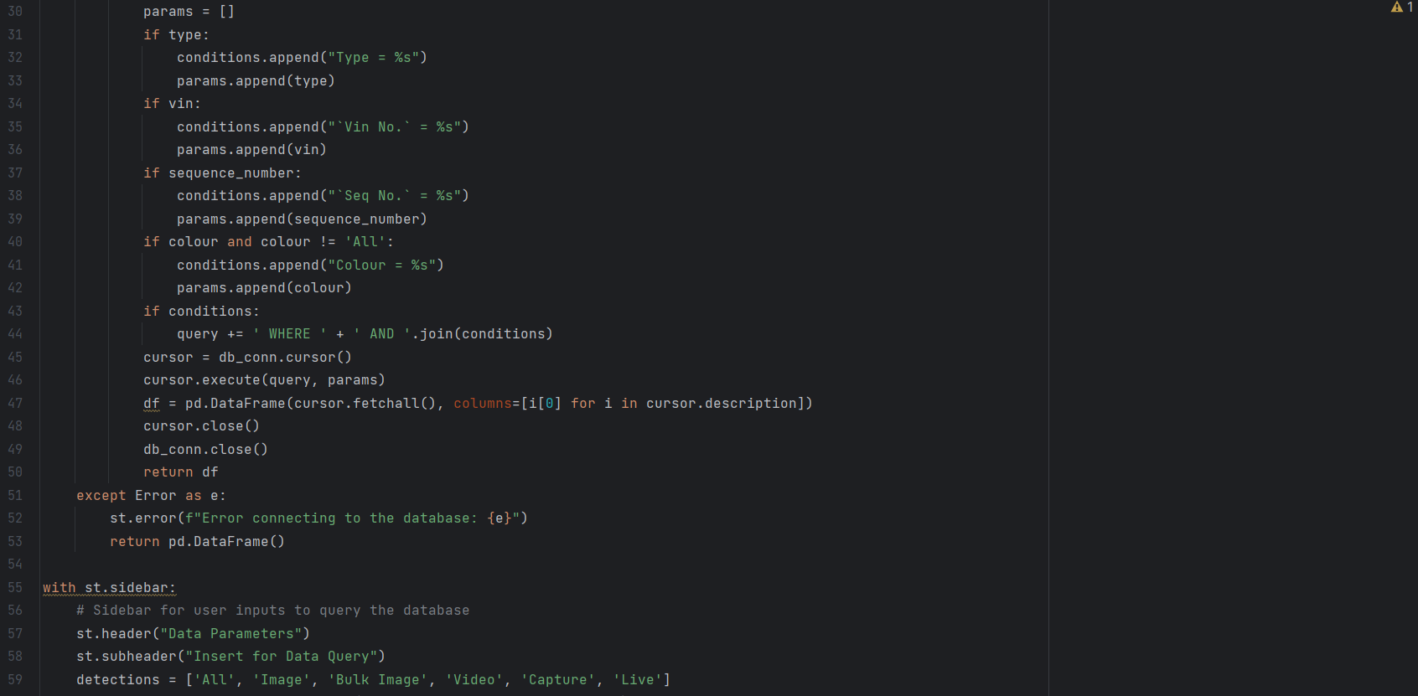 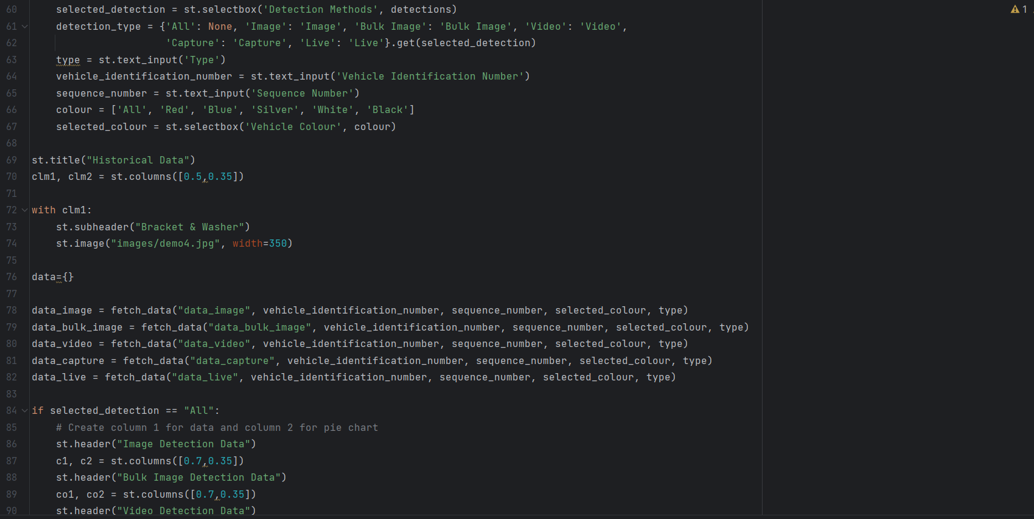 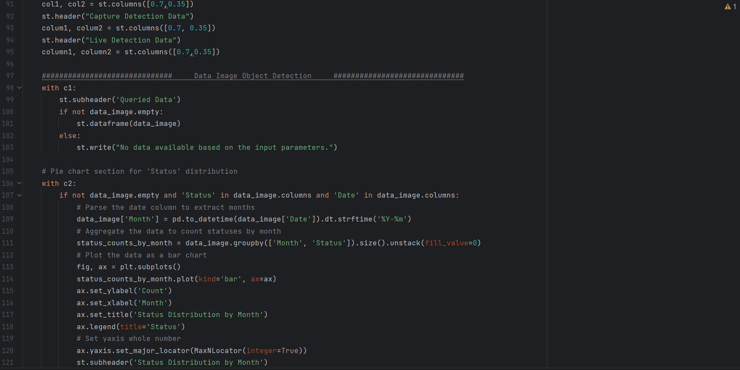 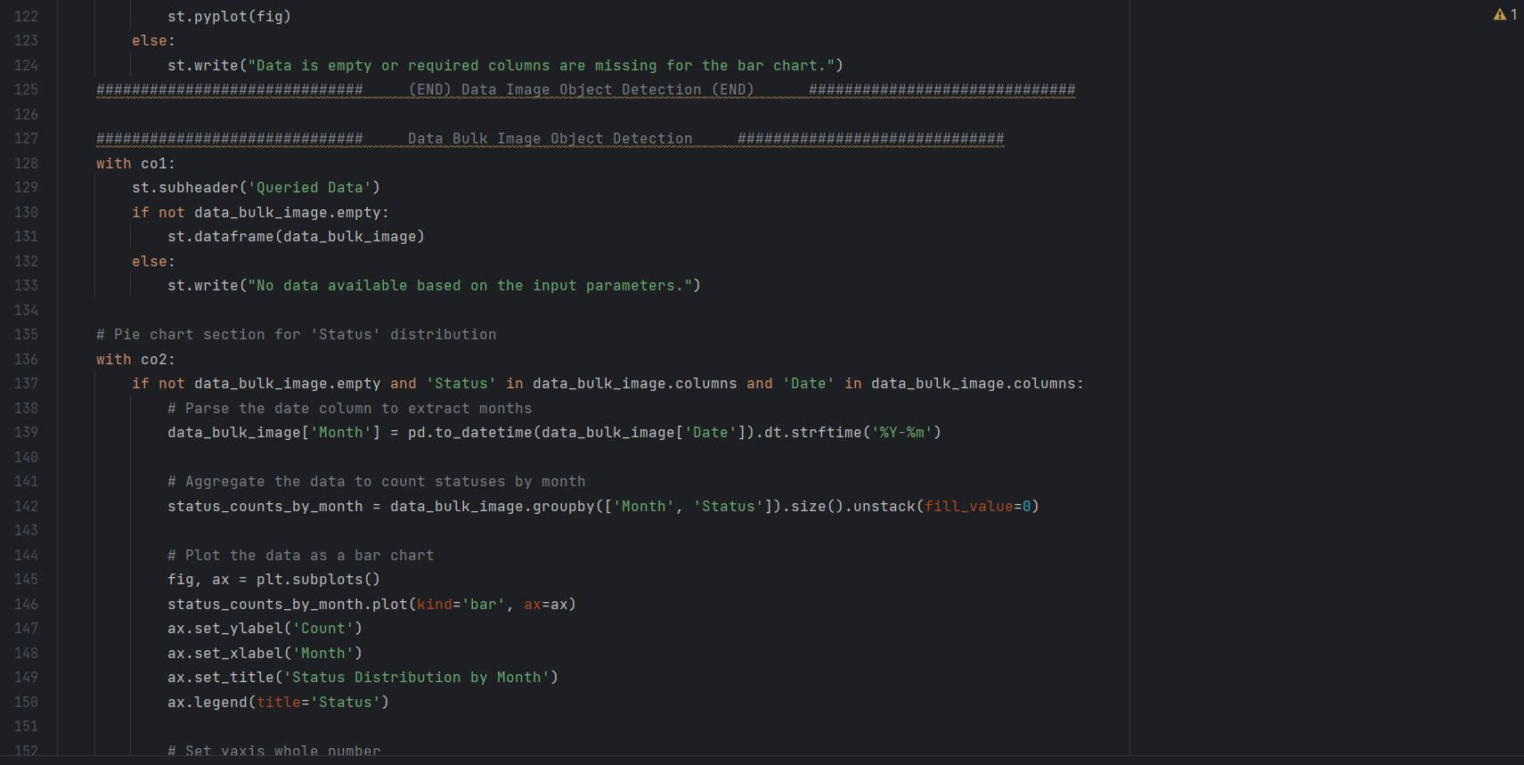 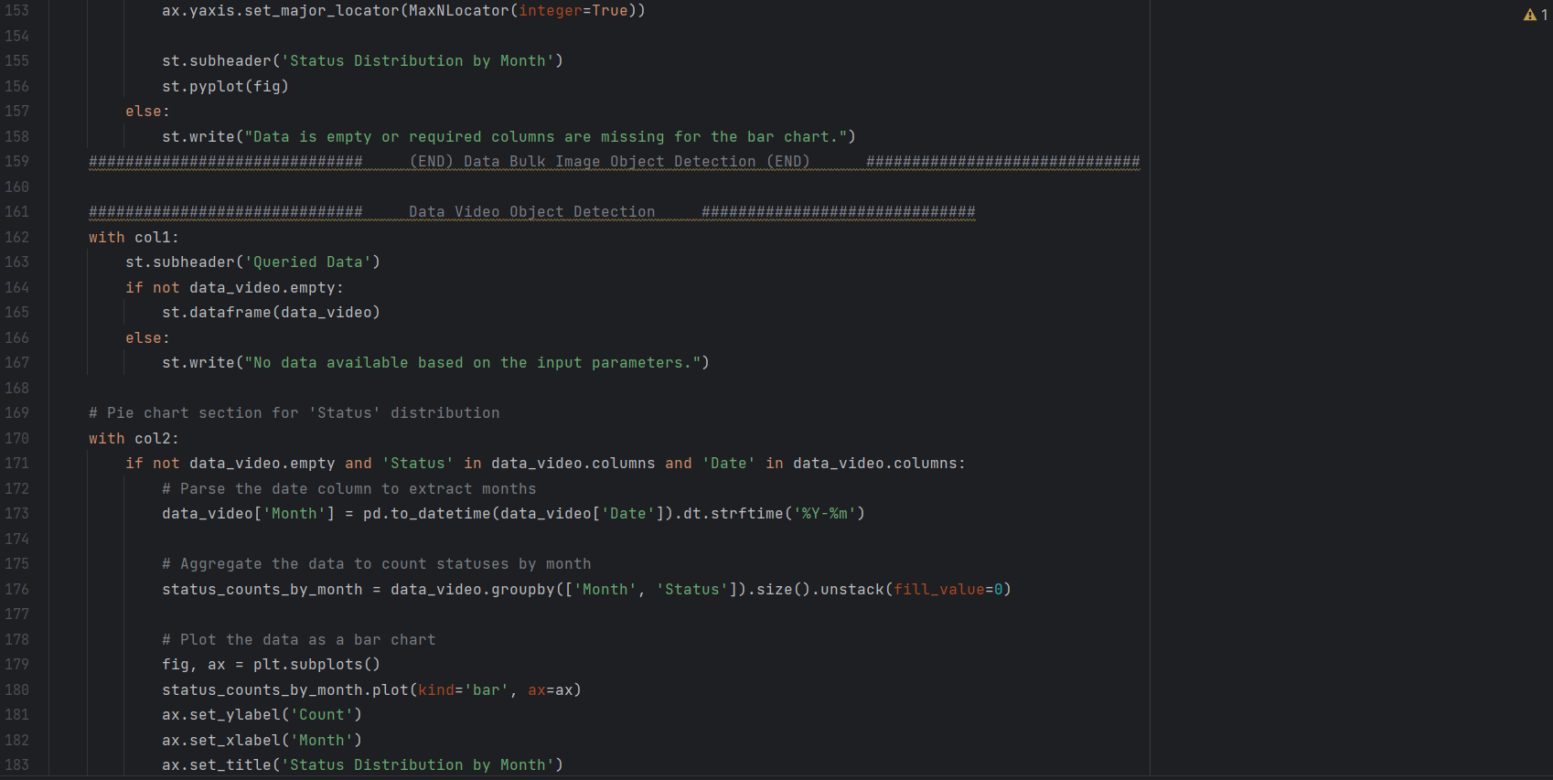 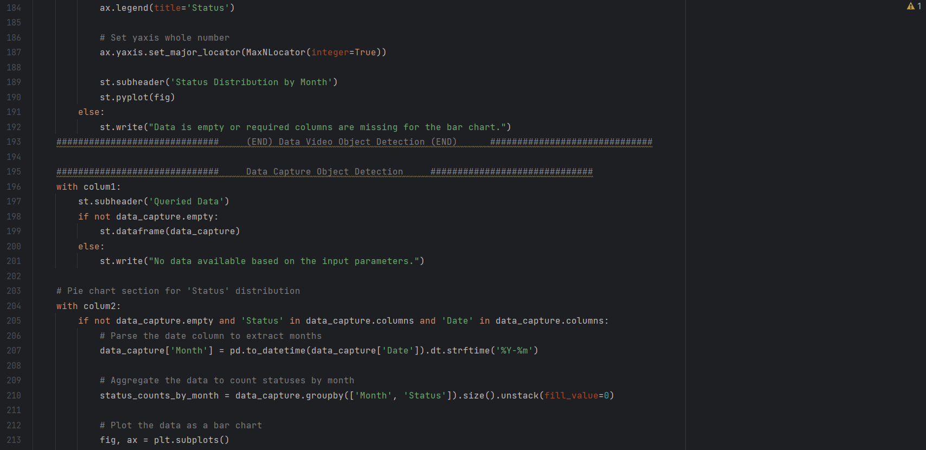 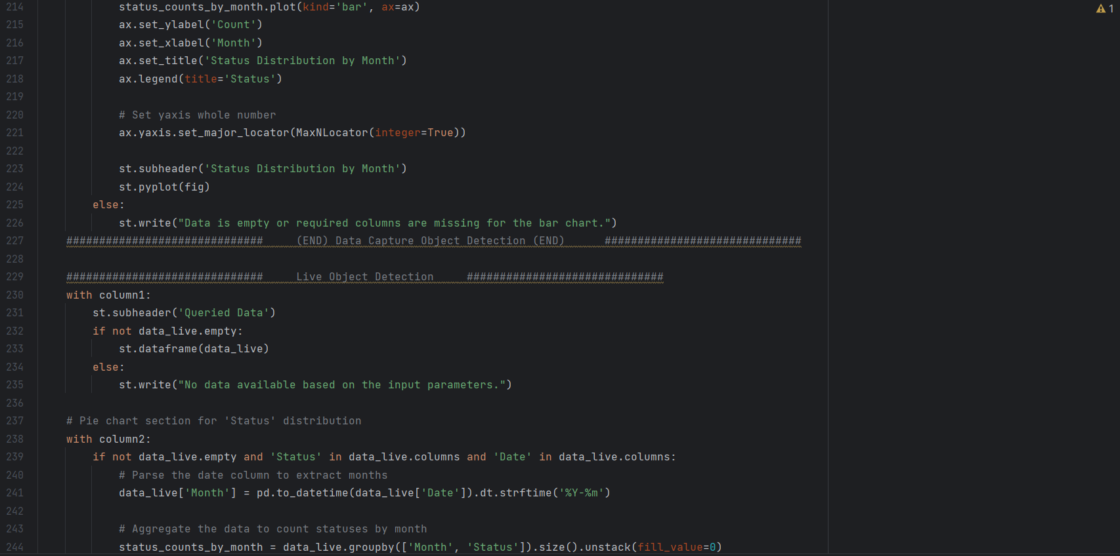 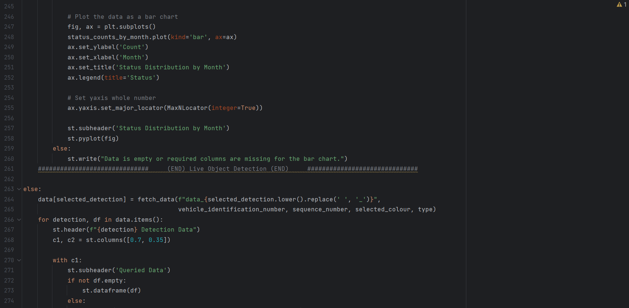 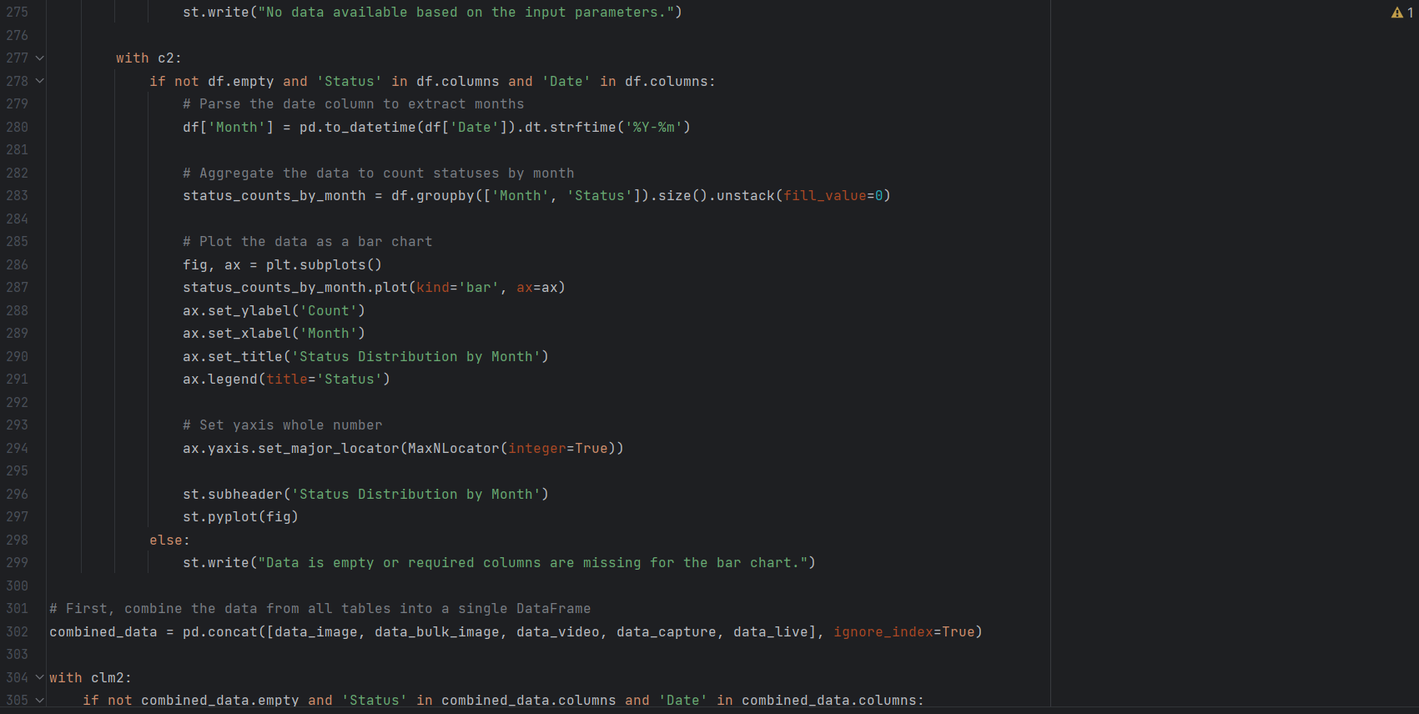 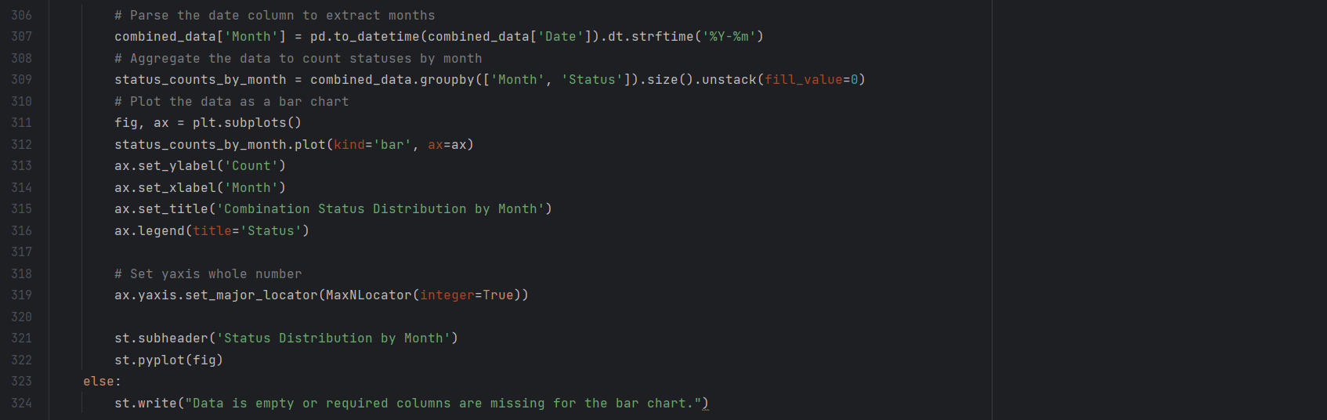

Appendix C: Image Object Detection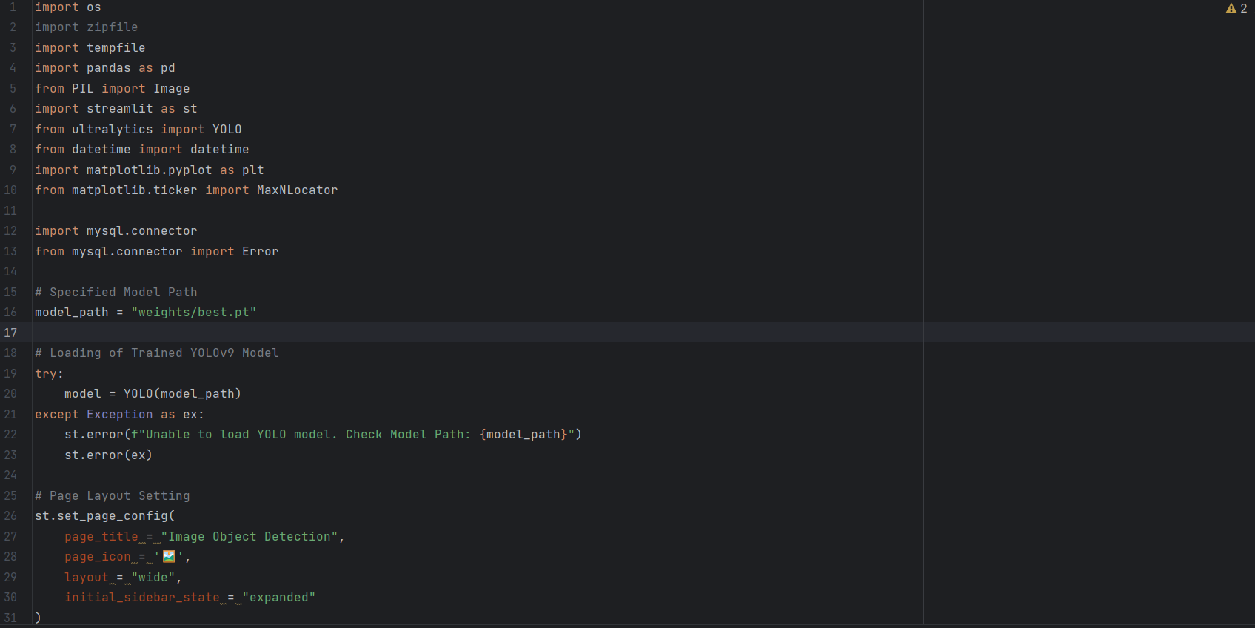

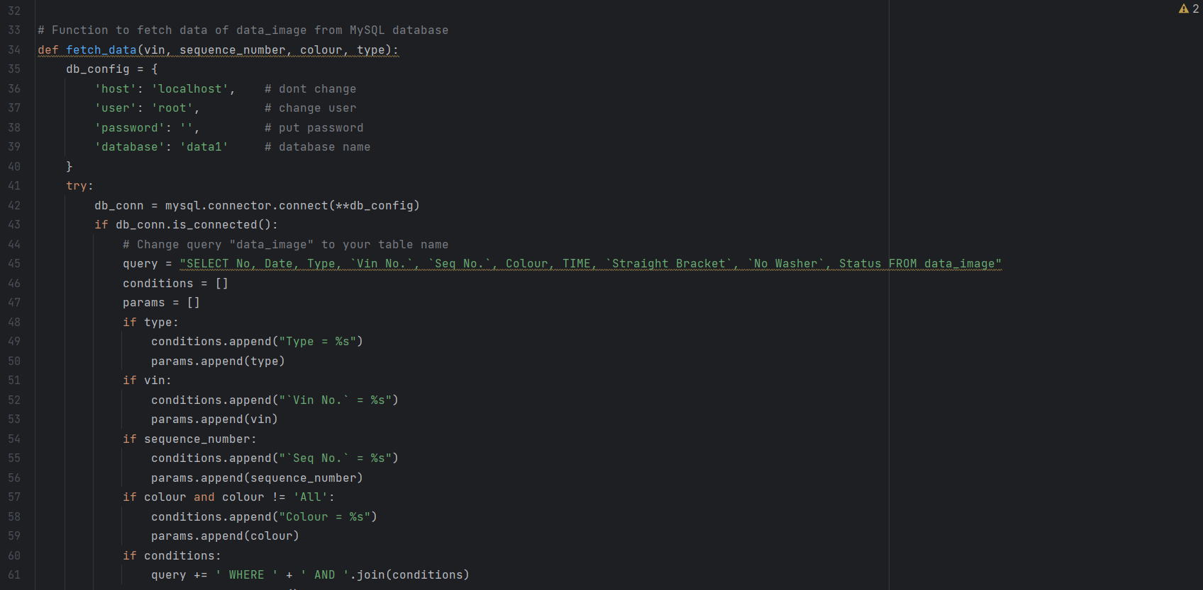 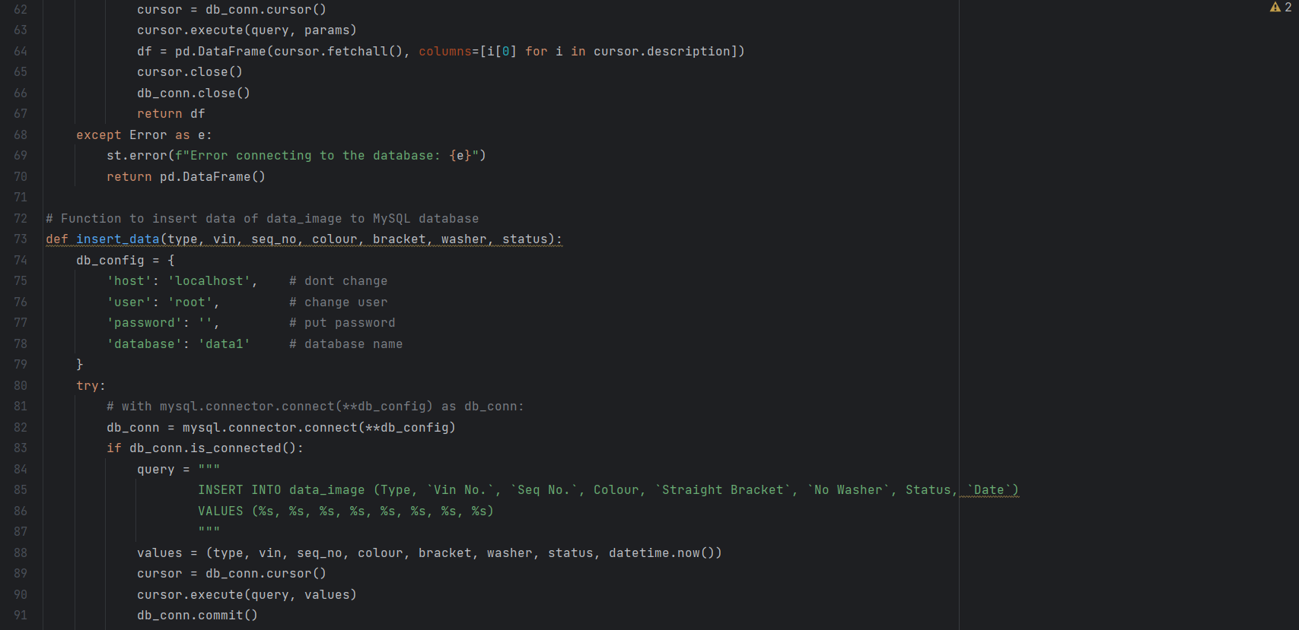 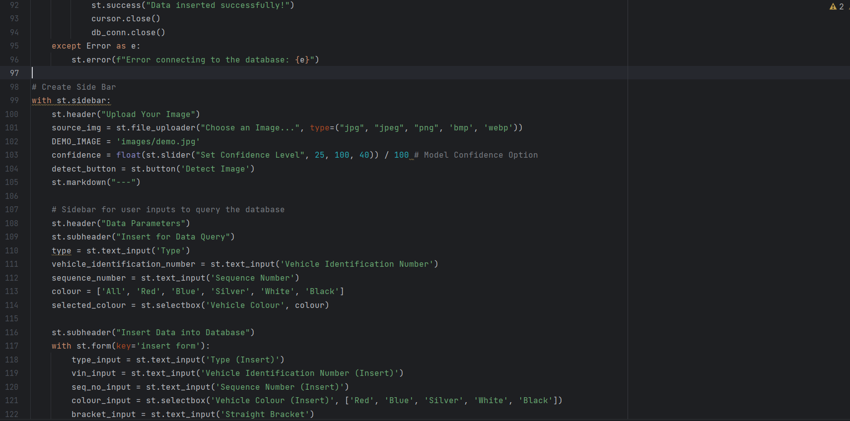 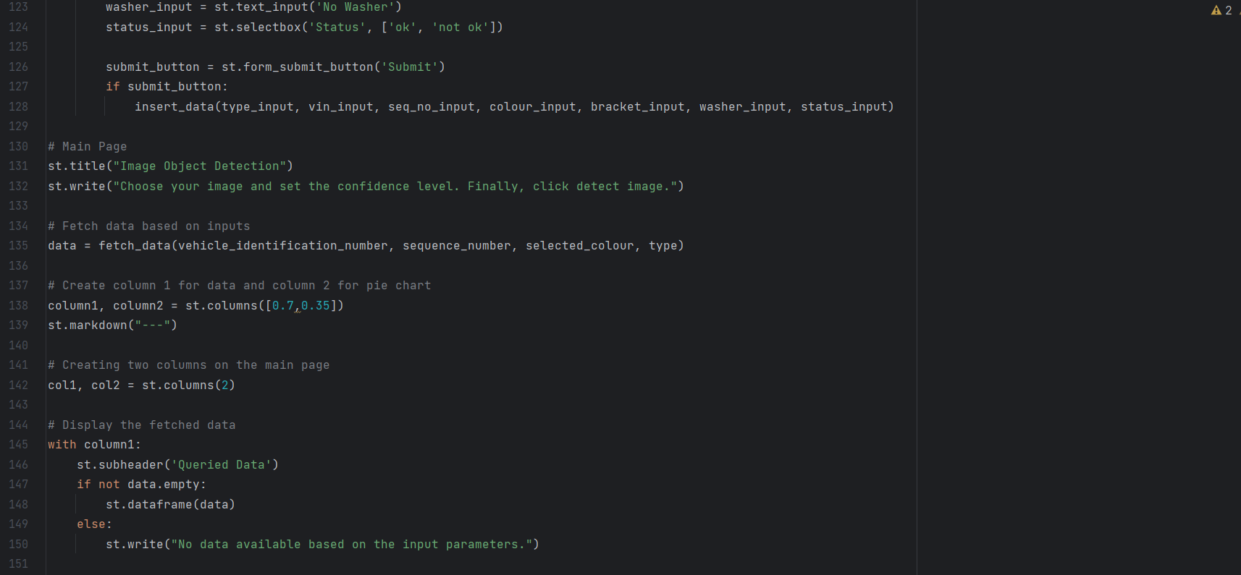 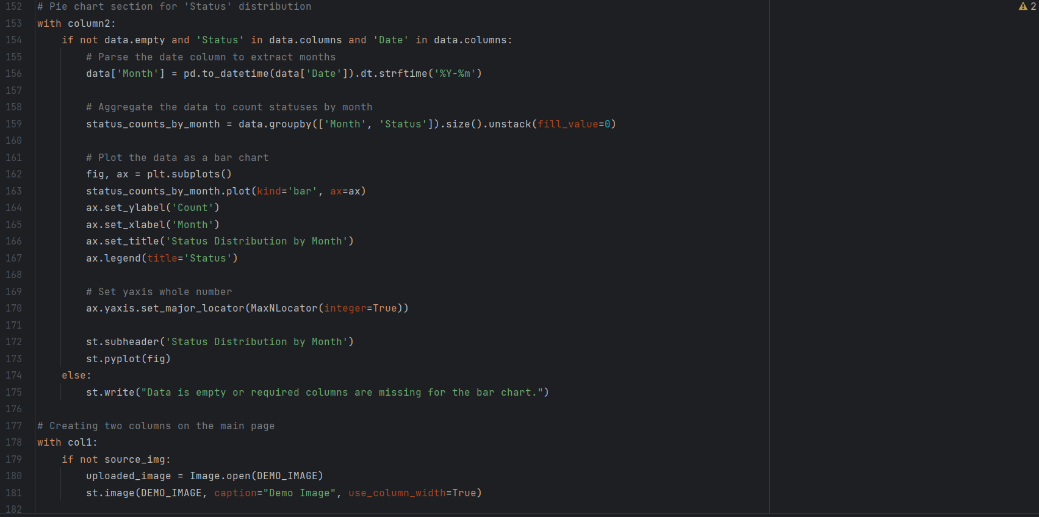 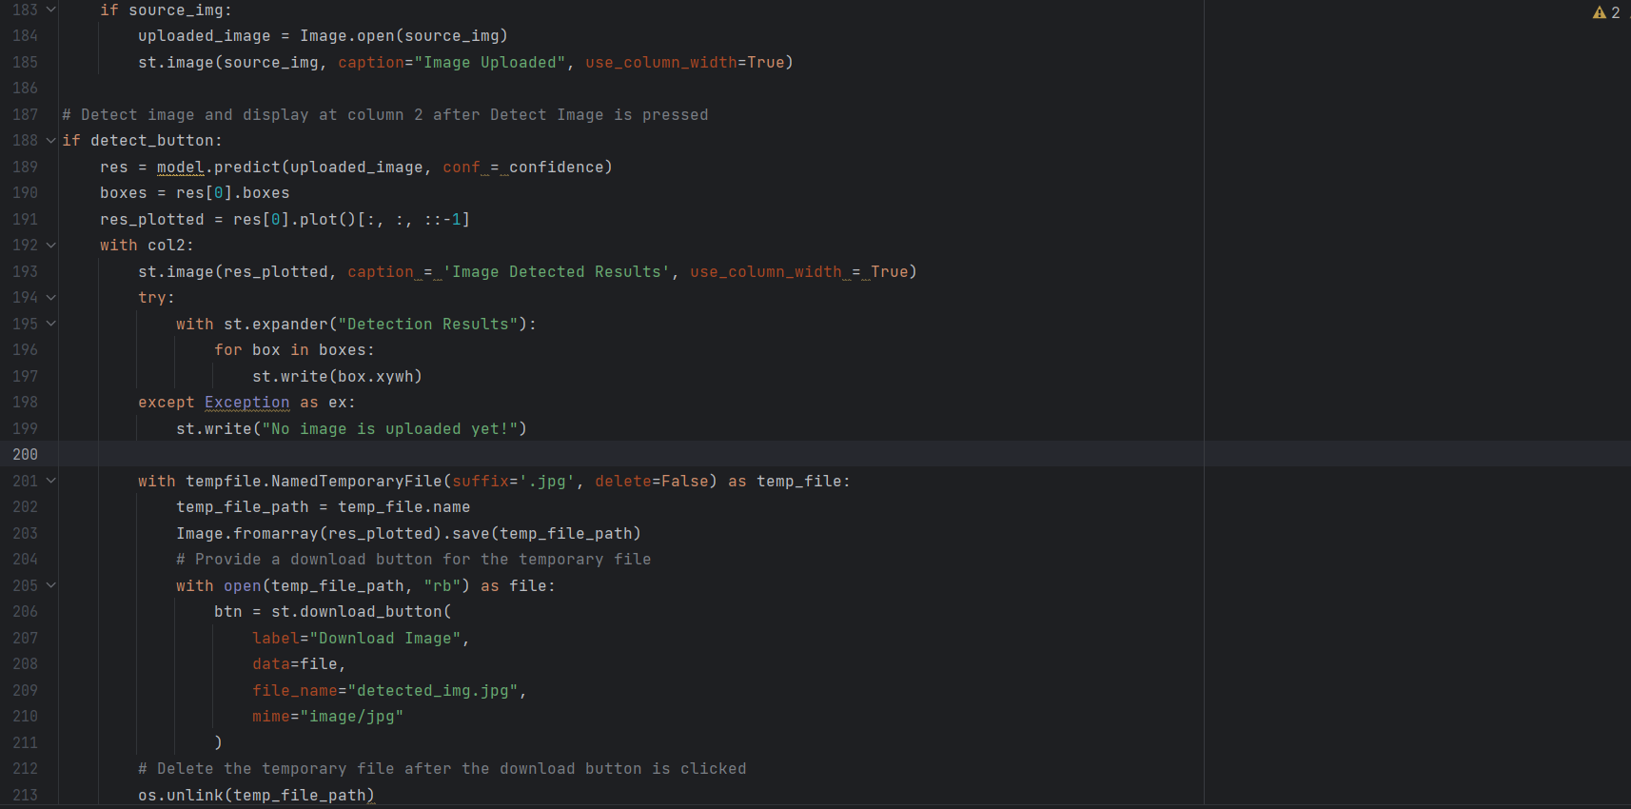

Appendix D: Bulk Image Object Detection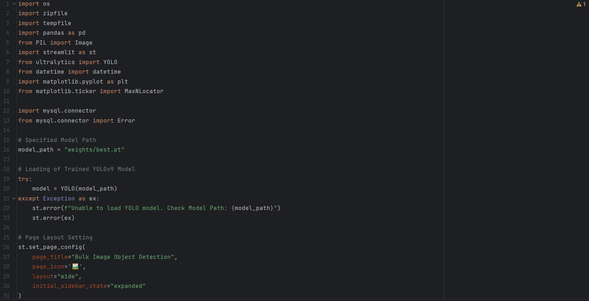

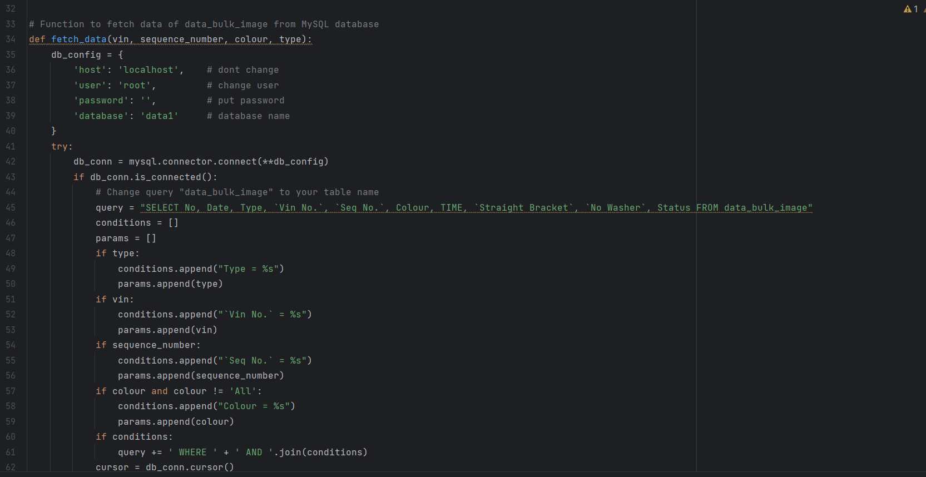 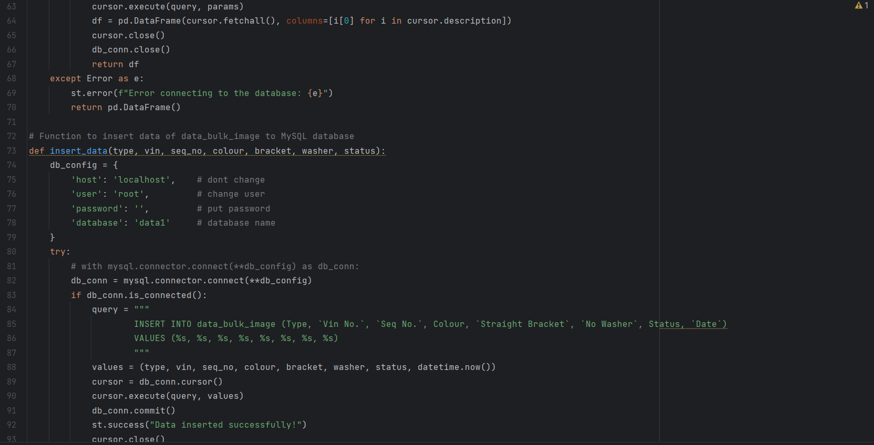 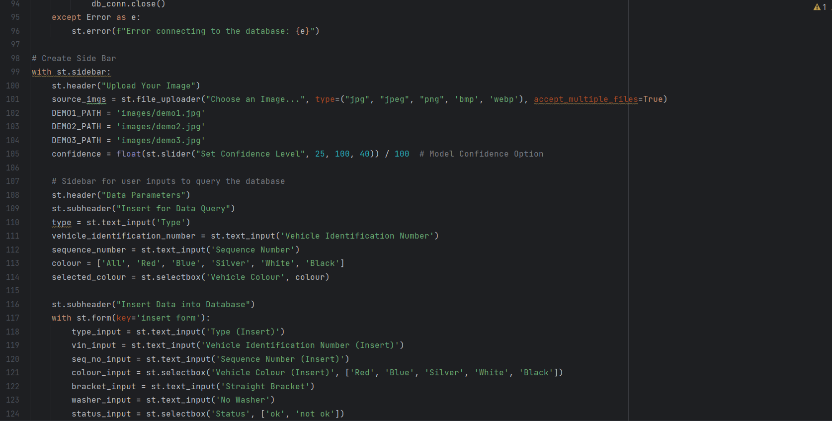 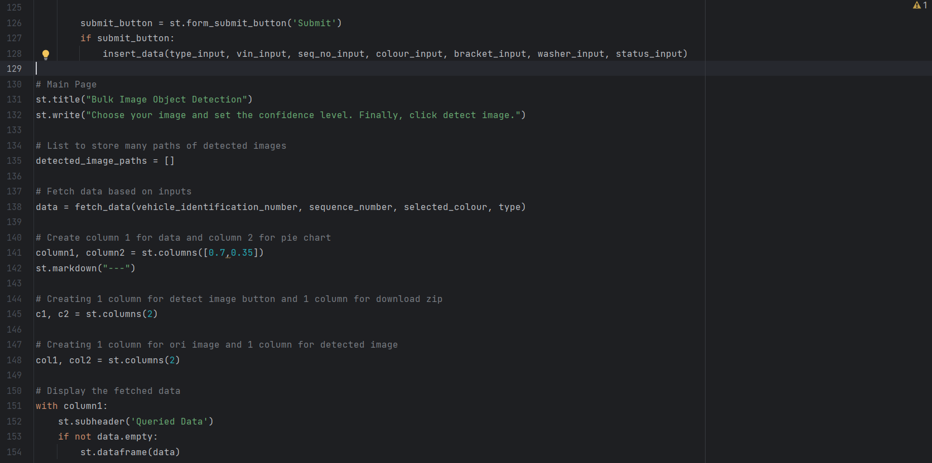 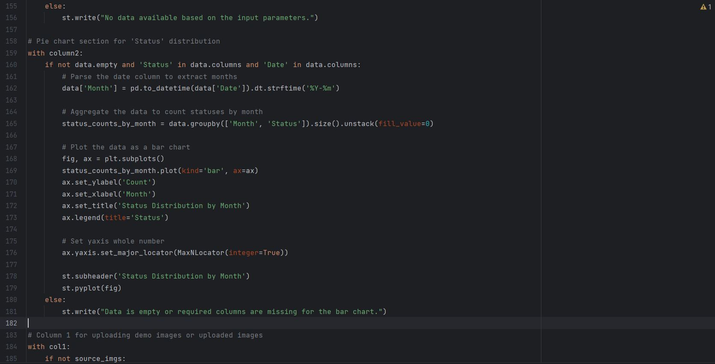 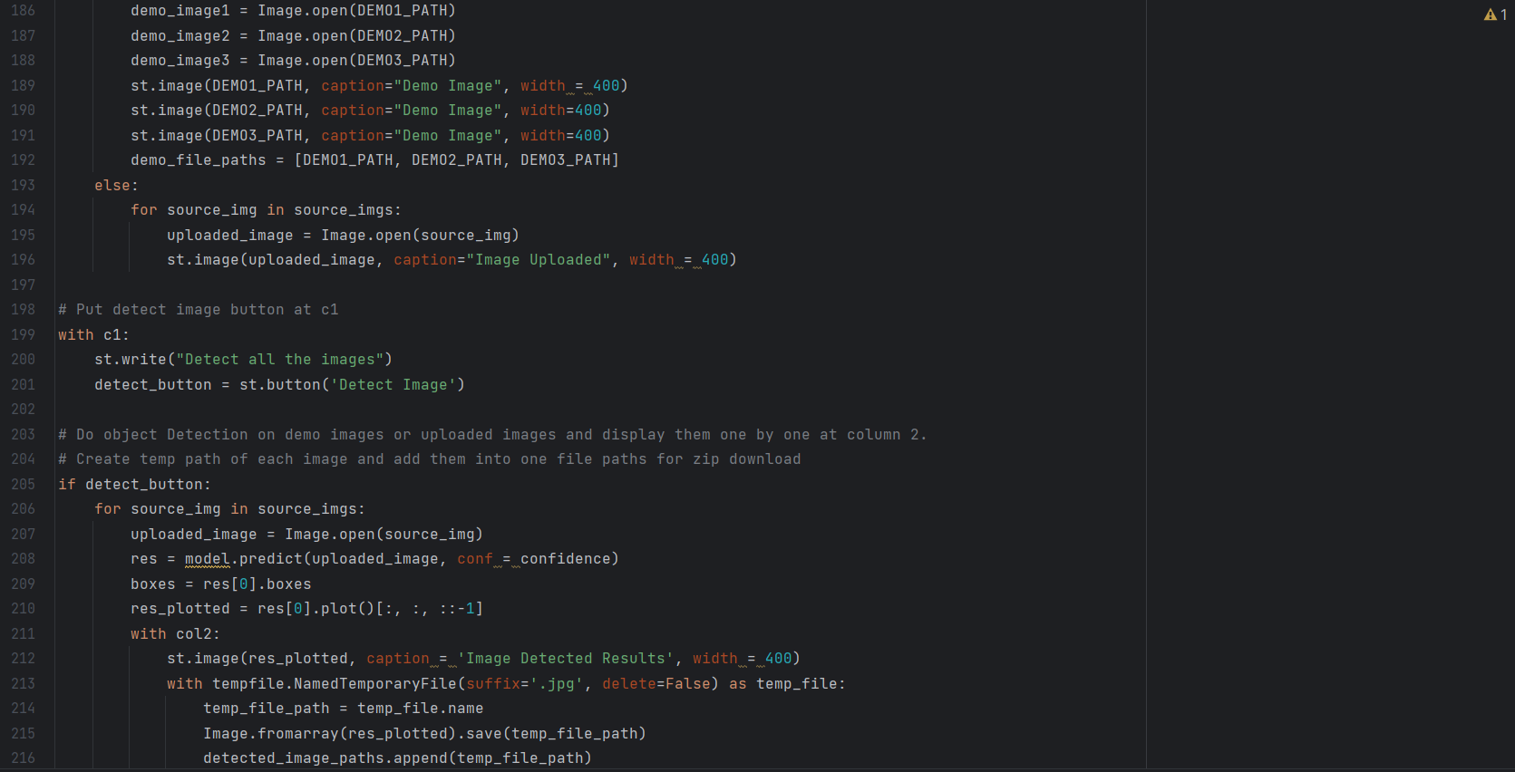 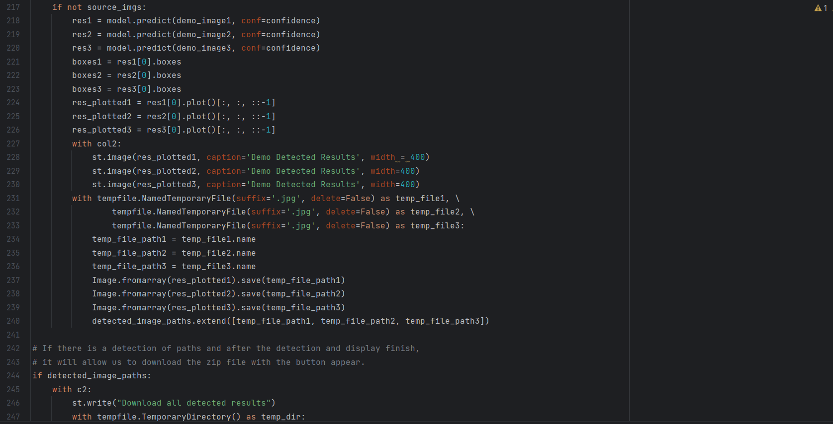 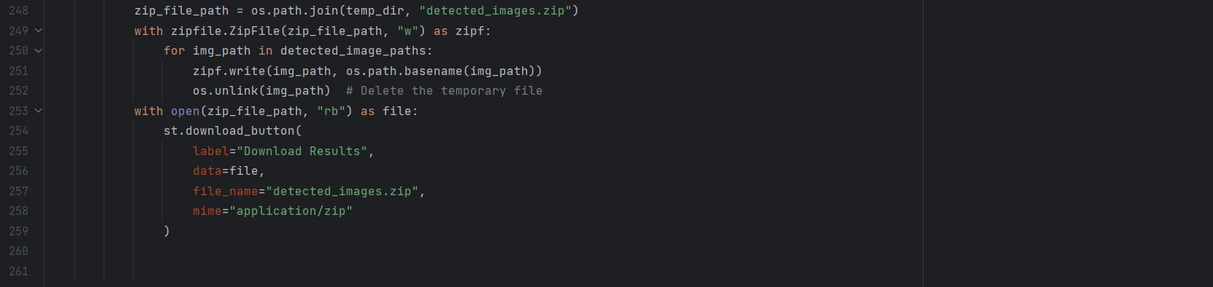

Appendix E: Video Object Detection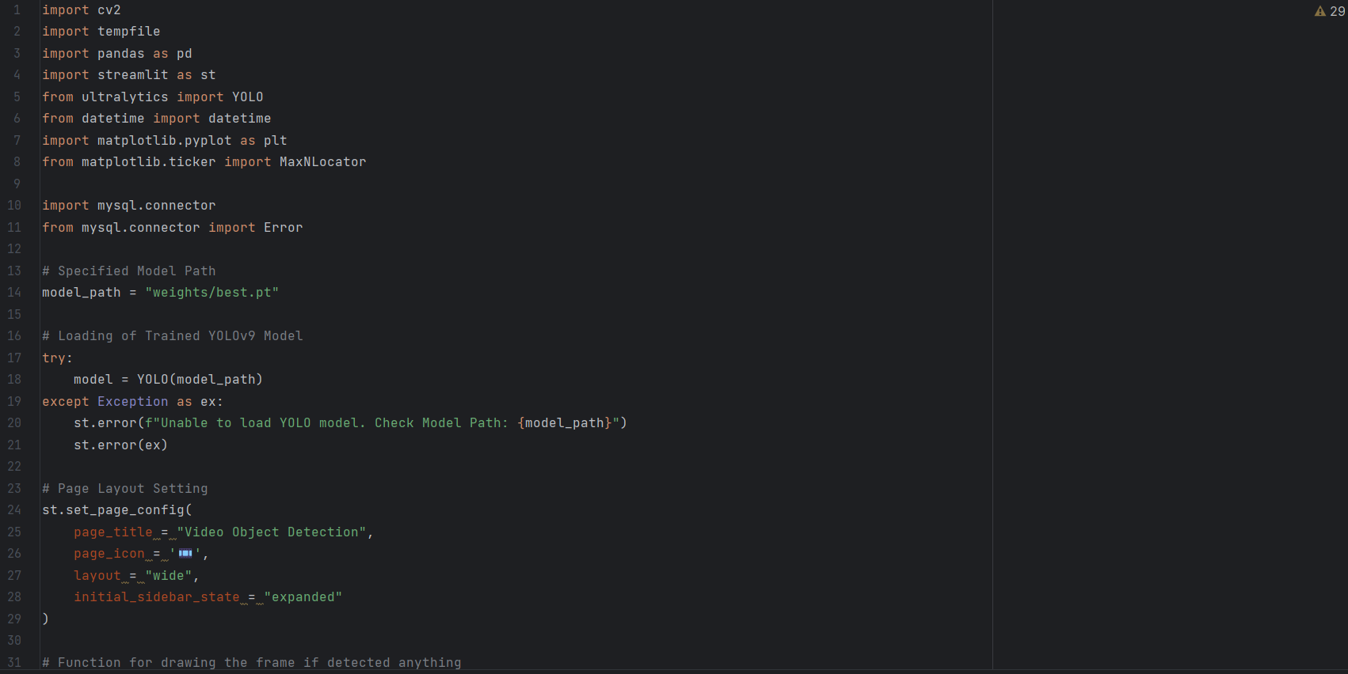

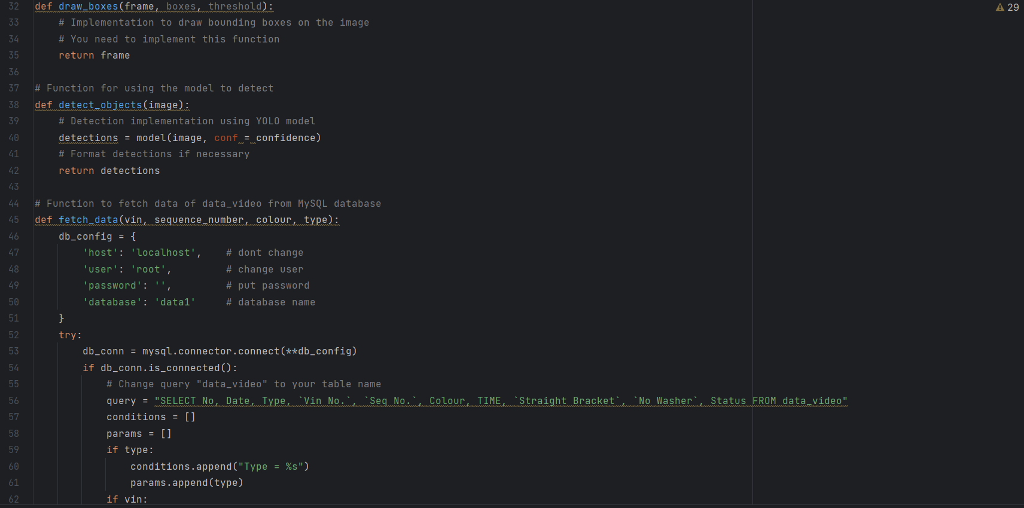 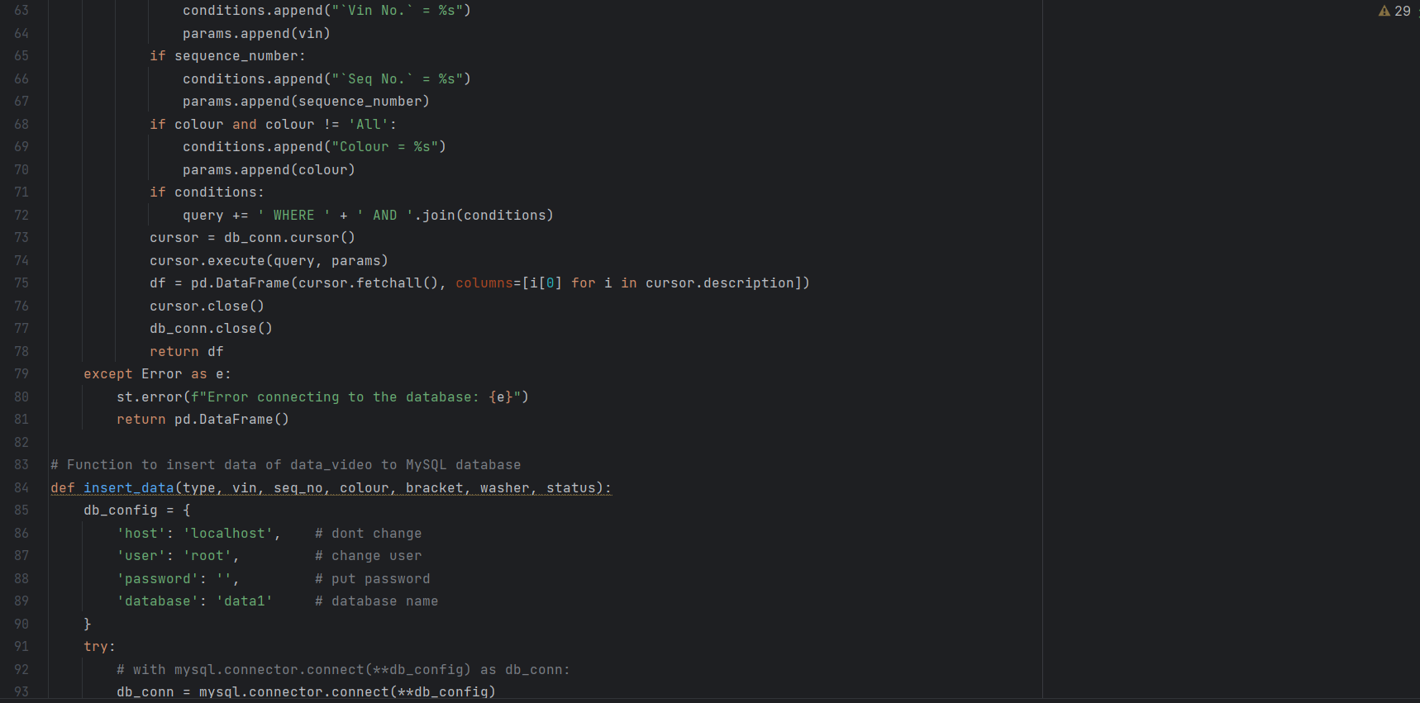 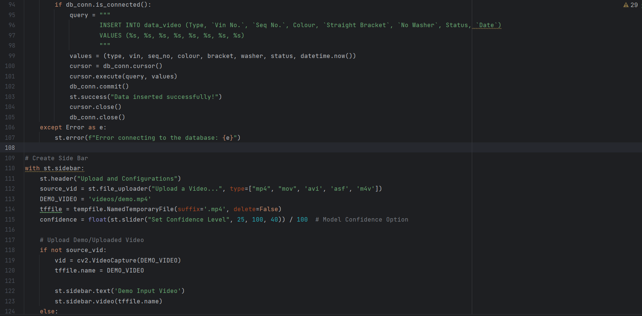 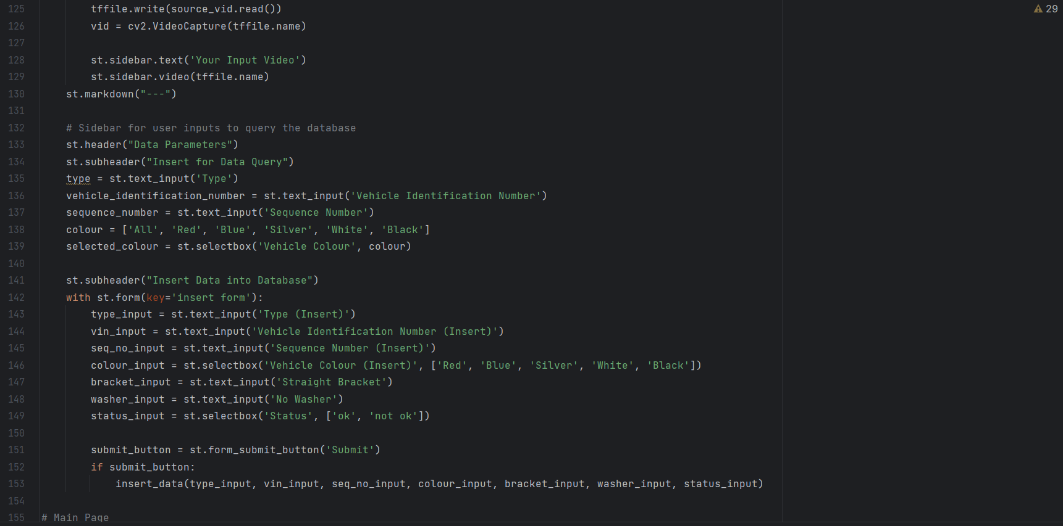 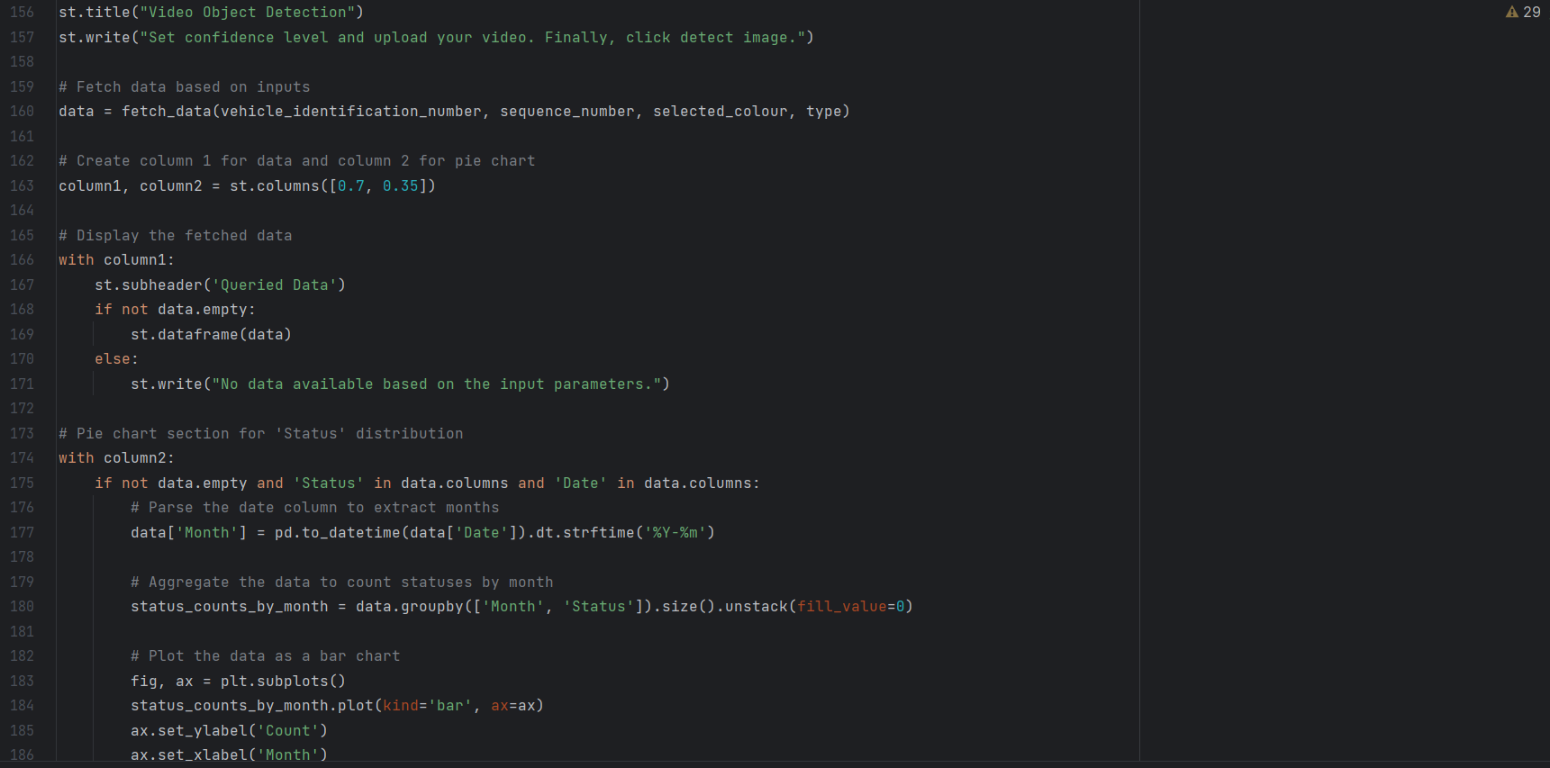 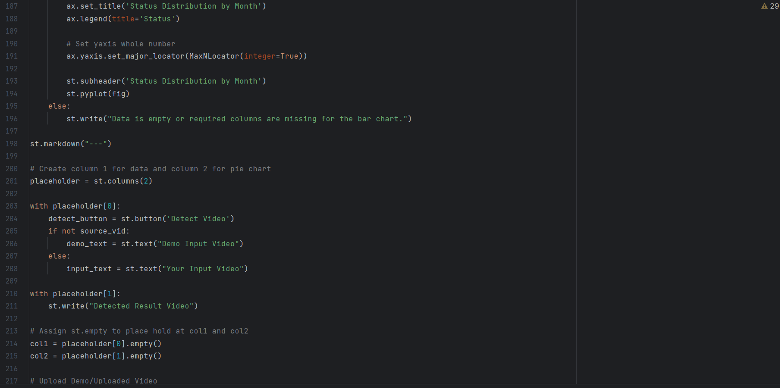 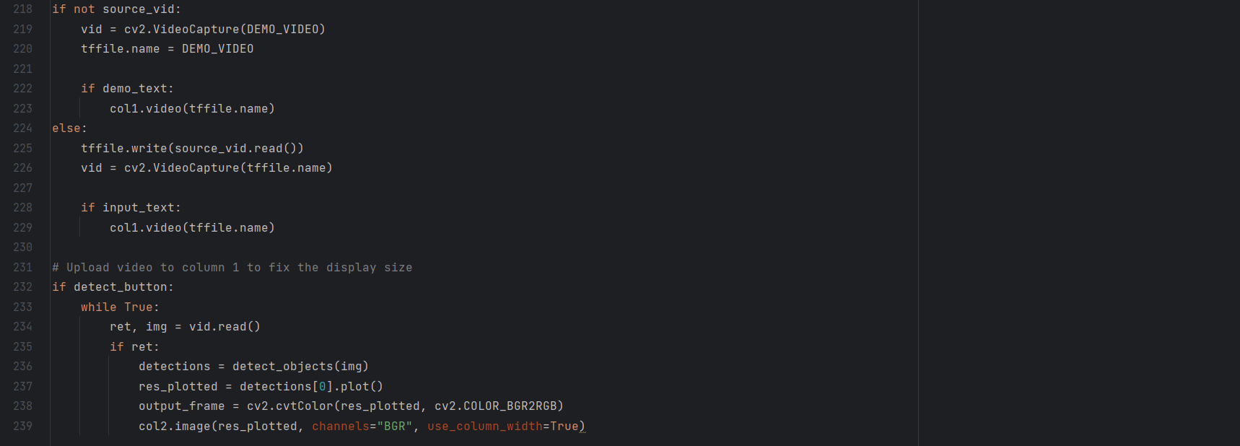

Appendix F: Capture Object Detection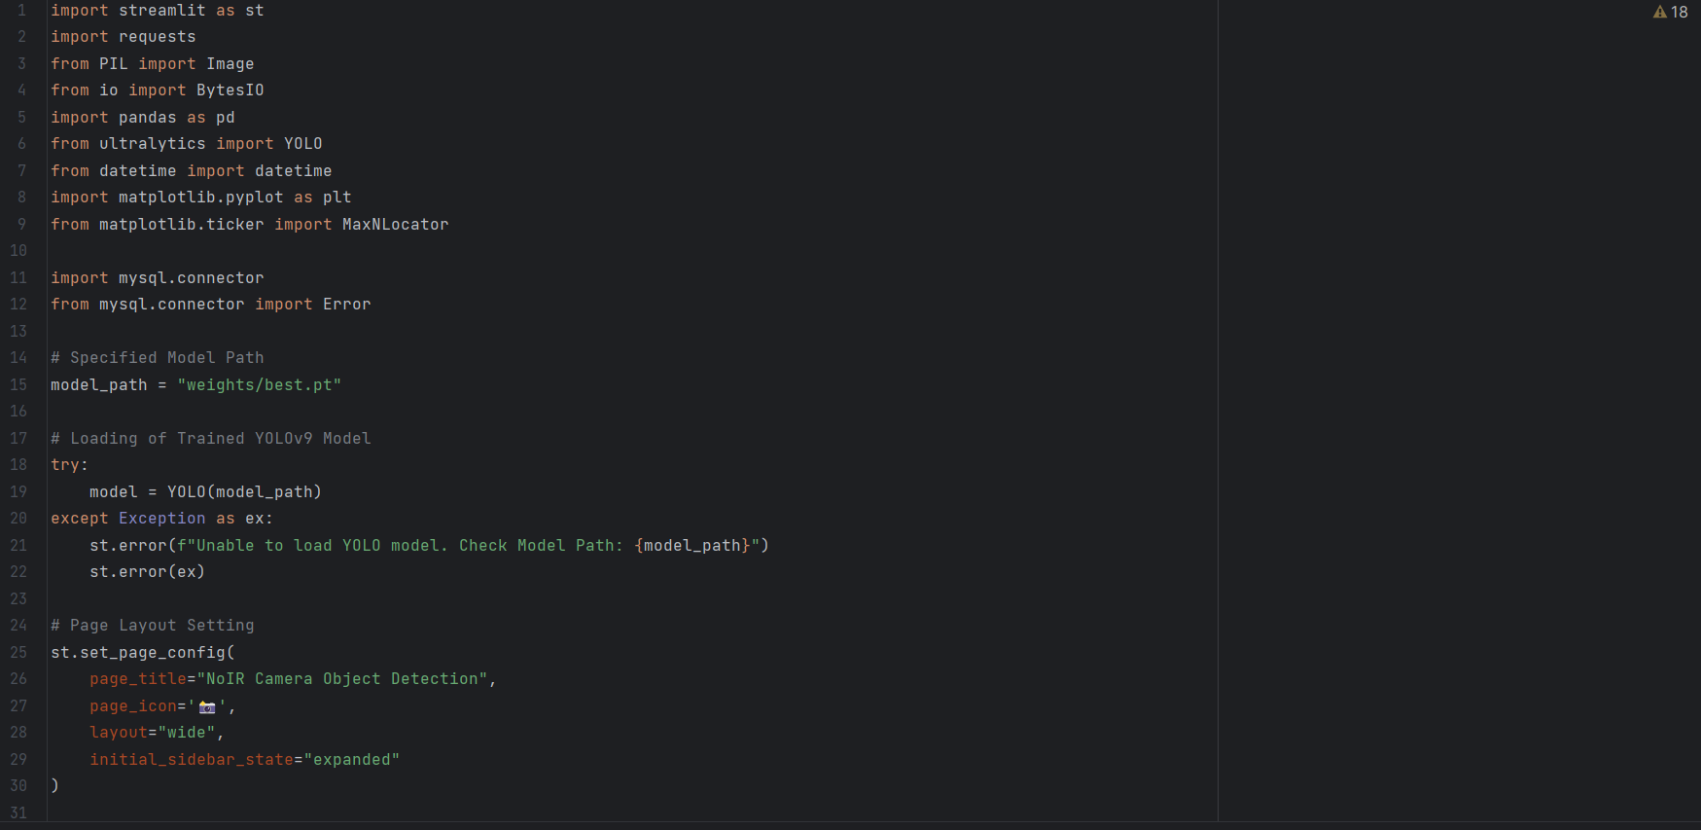

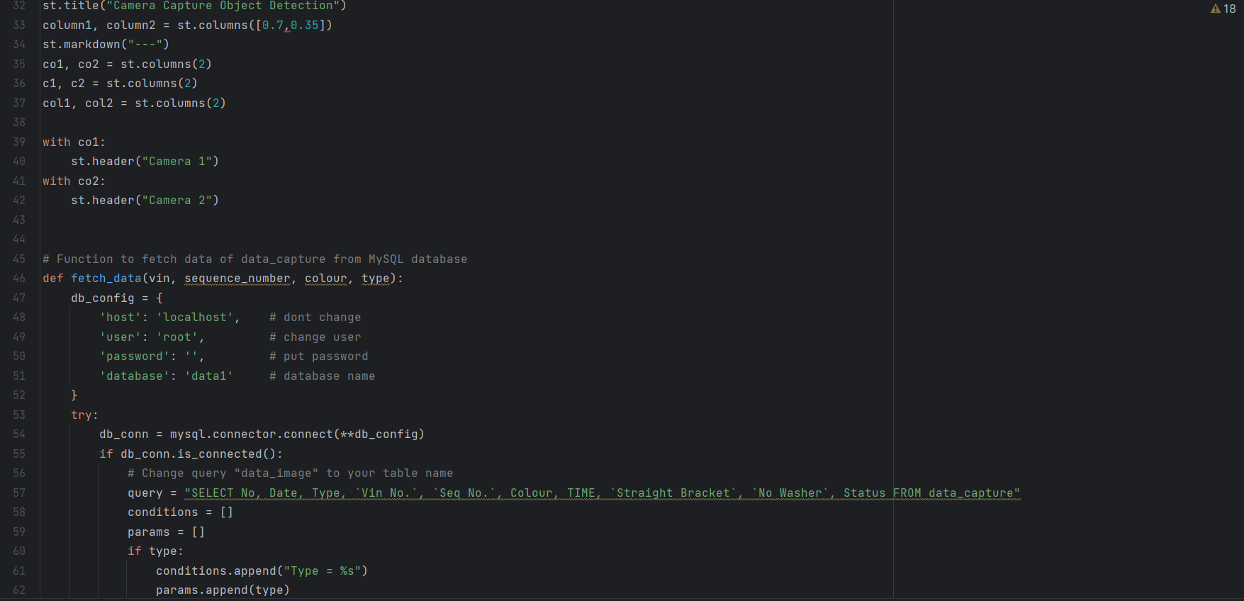 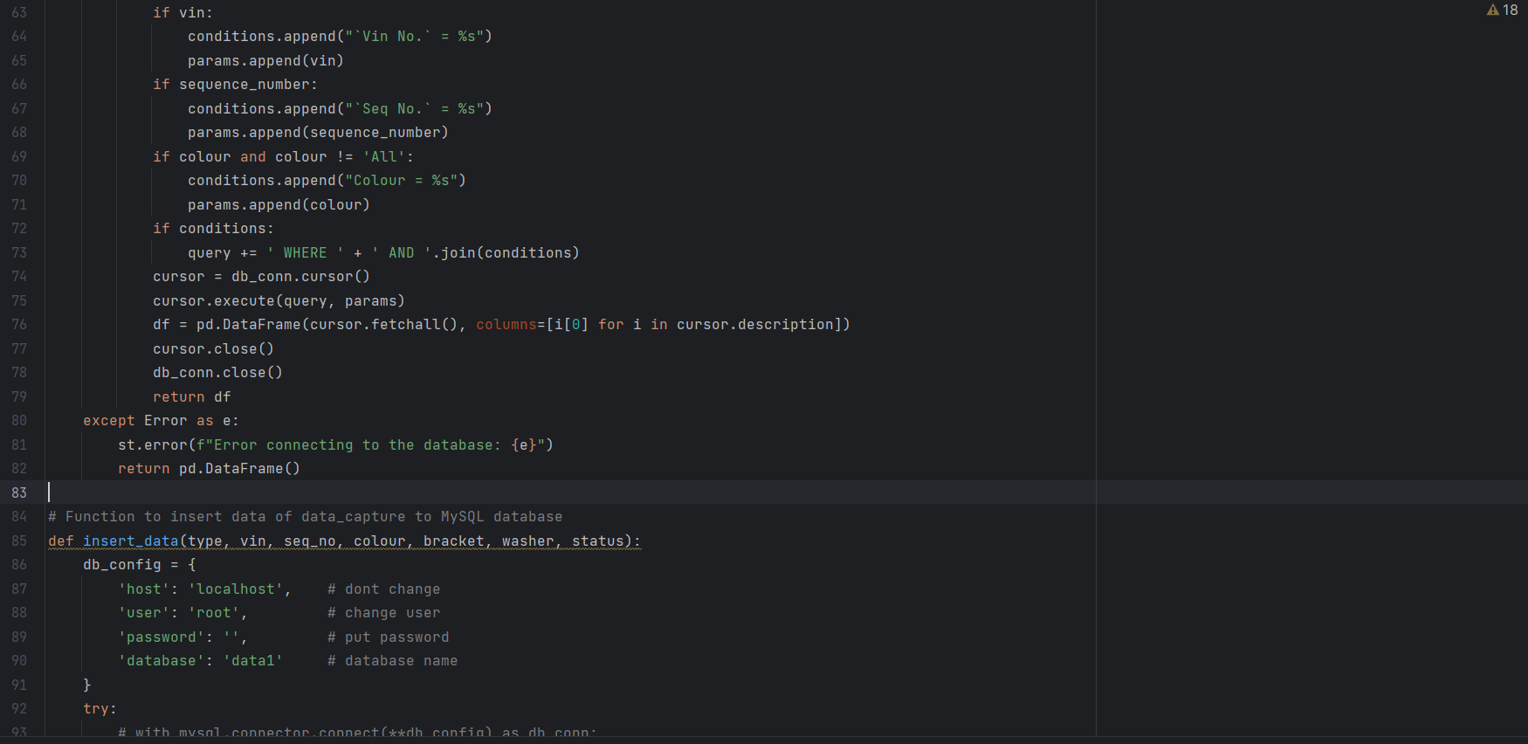 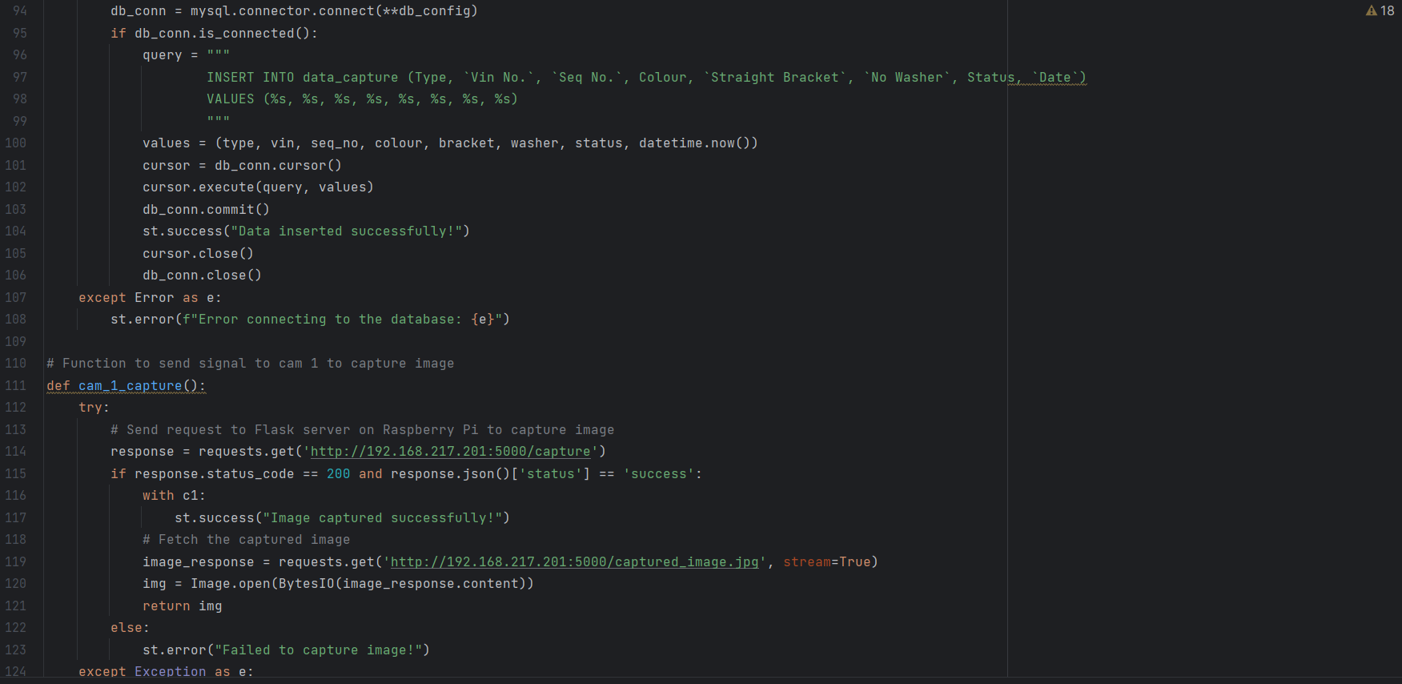 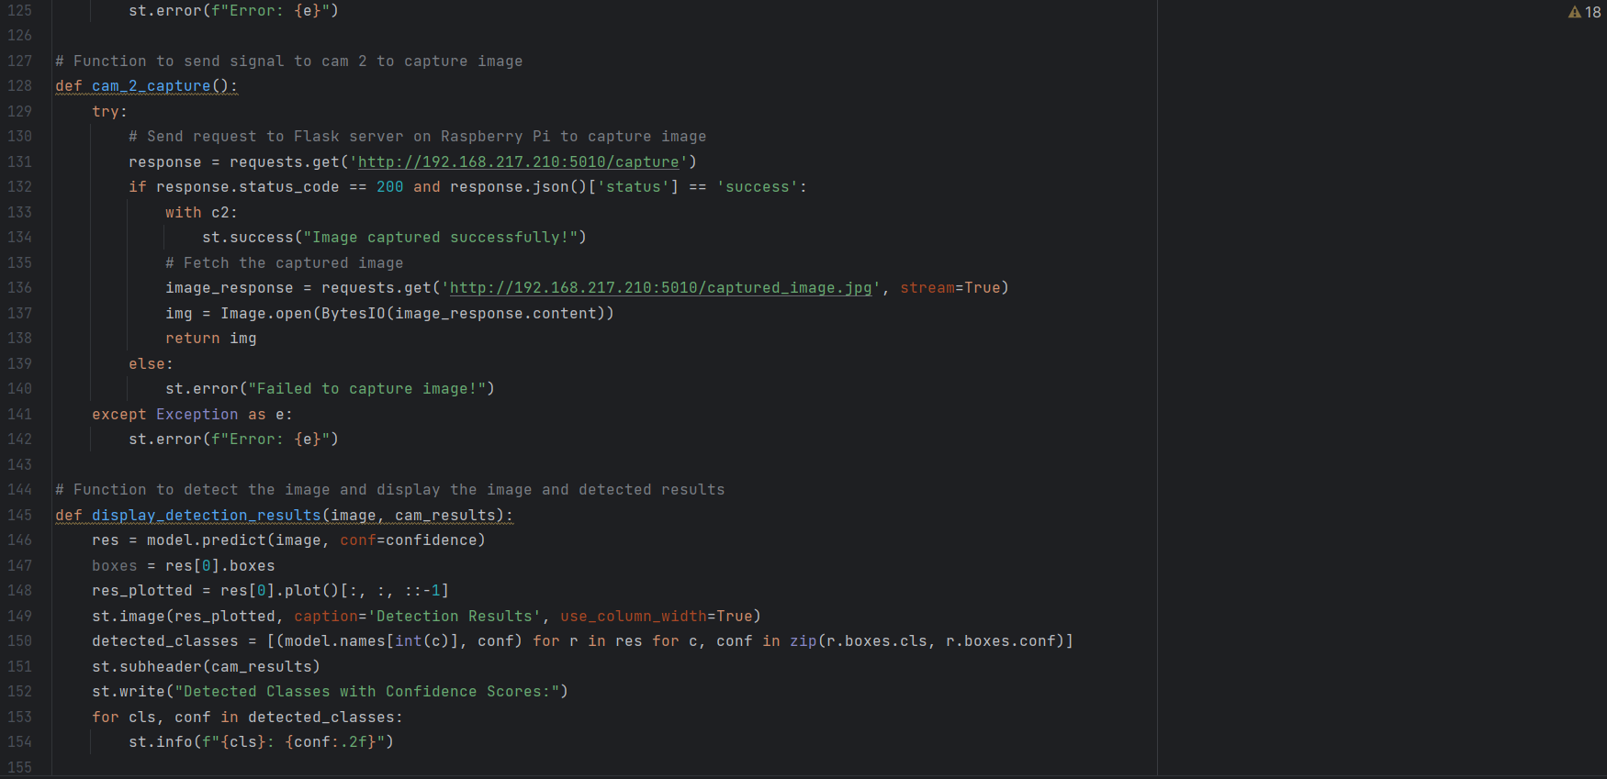 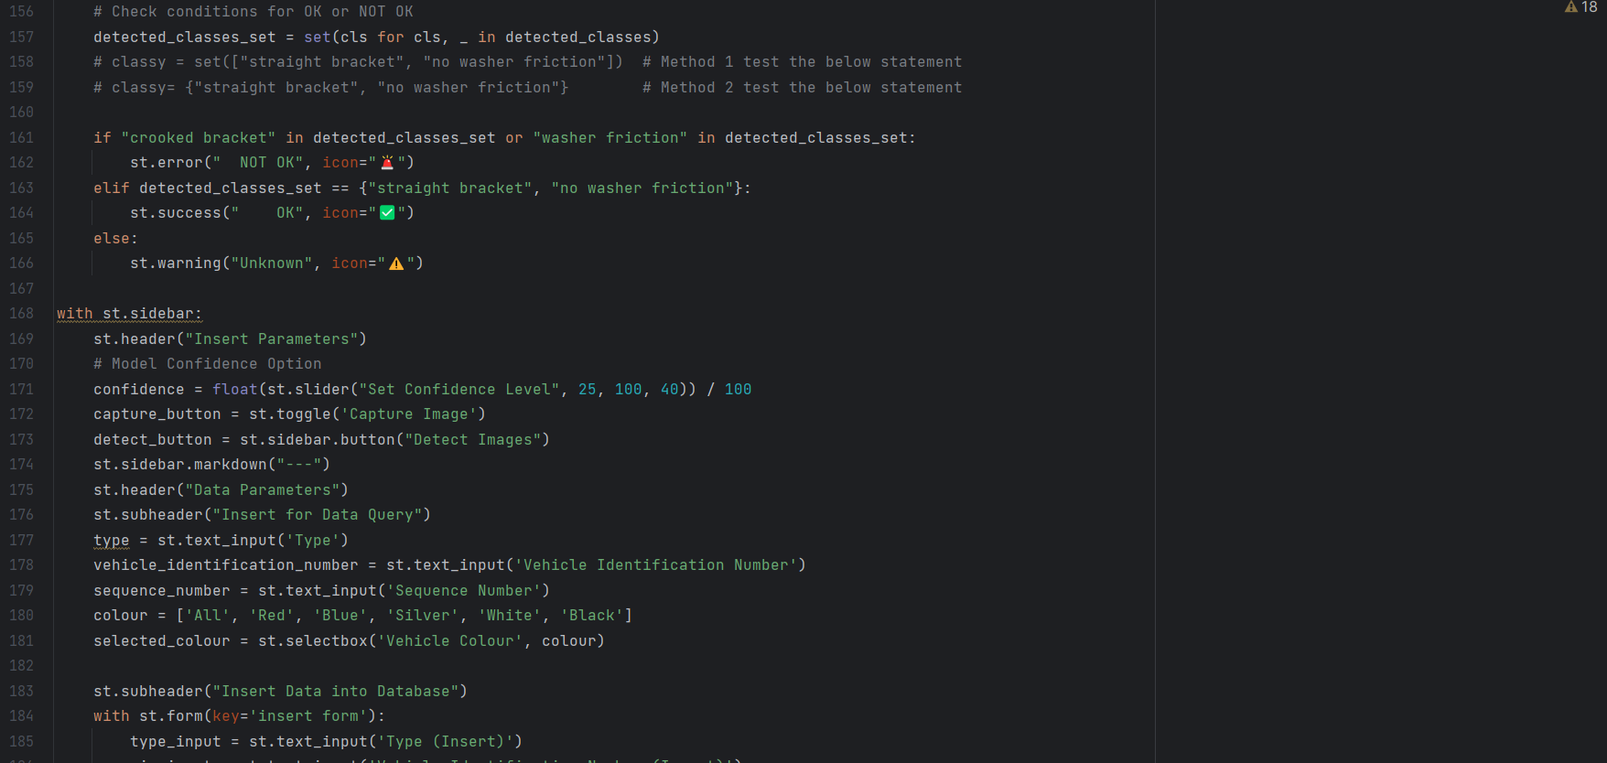 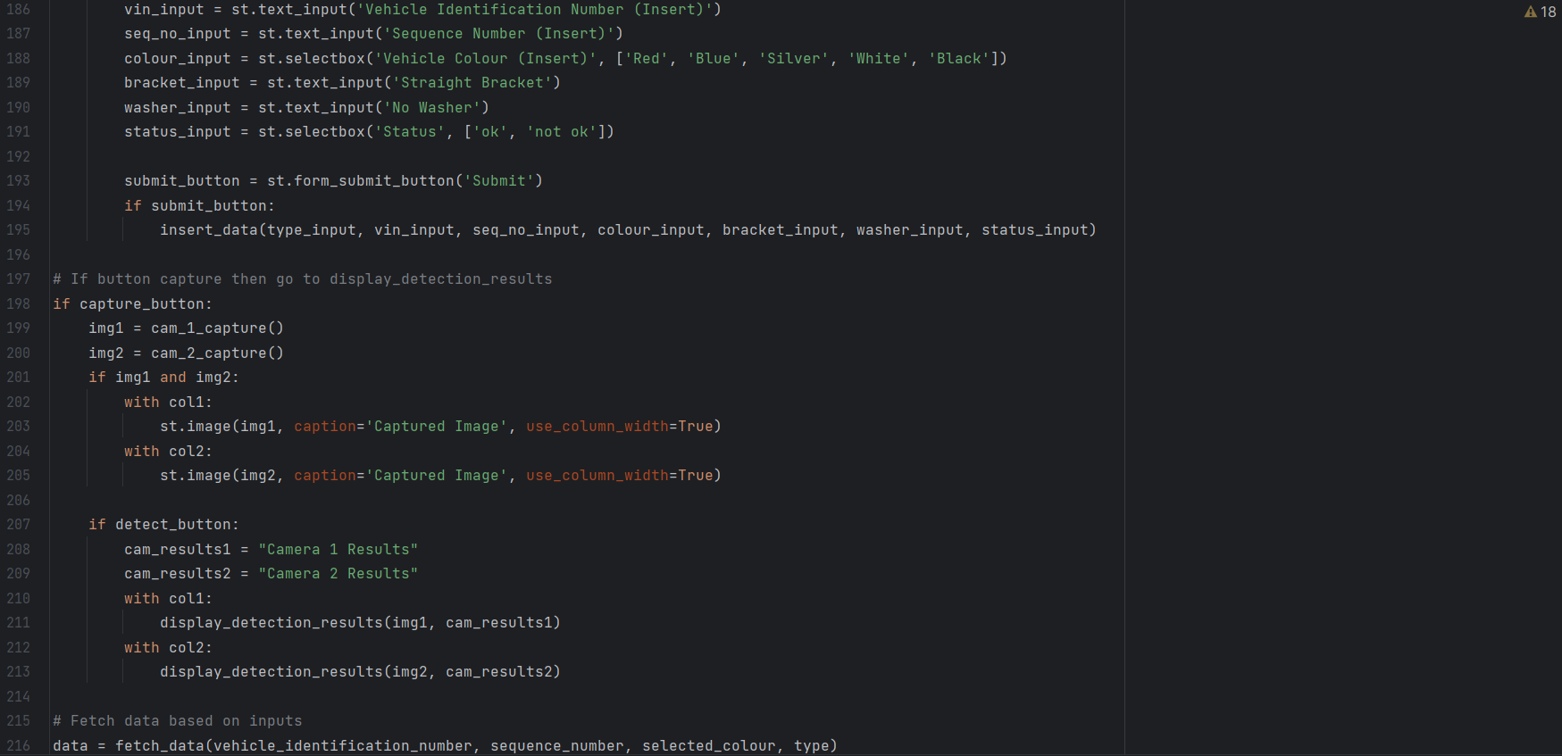 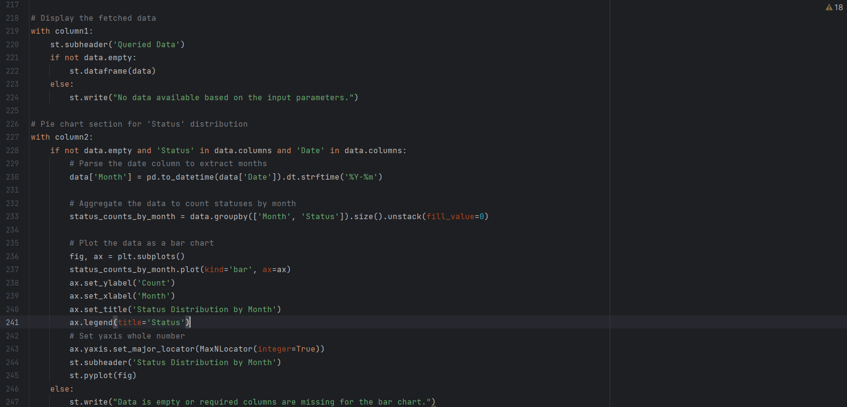

Appendix G: Live Object Detection